Reflection Based on the Seven Goals of Laudato Si’

Sisters of the Sacred Heart of Jesus of Bangkok

Introduction
The Encyclical entity[“book”,“Laudato Si’”,“Encyclical by Pope Francis”] by entity[“people”,“Pope Francis”,“Catholic Church”] invites all humanity to recognize that “our common home” belongs to everyone and that all creation is deeply interconnected — humanity, nature, economy, society, and spirituality.
The Sisters of the Sacred Heart of Jesus of Bangkok are aware of both the cry of the earth and the cry of the poor. Therefore, the Congregation strives to live and carry out its mission with the spirituality of love, service, and sharing according to the spirit of the Sacred Heart of Jesus.
Reflecting on the Seven Goals of Laudato Si’ helps us realize that our various ministries are not merely social activities, but a collaboration with God in caring for creation, restoring human dignity, and building a world filled with hope, justice, and peace.

1. Response to the Cry of the Earth
The Congregation recognizes that the world is facing an environmental crisis, including global warming, pollution, excessive consumption of resources, and the destruction of ecosystems. These realities directly affect human life, especially the poor and the vulnerable.
Therefore, the Sisters join together in caring for our common home through activities such as tree planting, waste separation, organic compost production, carbon reduction, and living according to the Sufficiency Economy philosophy. Learning centers on environmental awareness have also been developed in communities and schools.
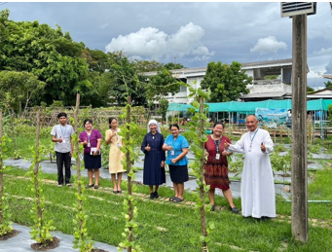

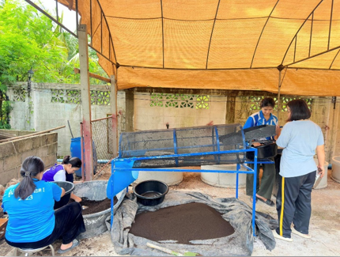

These efforts are not only acts of environmental conservation, but expressions of gratitude to the Creator and opportunities to cultivate awareness among children, youth, and staff regarding the value of all creation.
We are continually invited to ask ourselves:
“Do we live with respect for God’s creation?”
and
“What kind of world are we leaving for future generations?”

2. Response to the Cry of the Poor
The spirituality of the Sacred Heart calls the members of the Congregation to recognize the face of Christ in the poor, the abandoned, and those who suffer.
The Sisters share their lives with vulnerable people in many ways: visiting the elderly, bedridden patients, prisoners, bereaved families, children and youth in crowded communities, and migrant workers from different ethnic backgrounds.

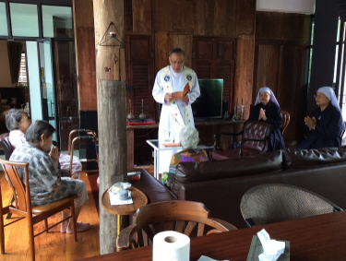

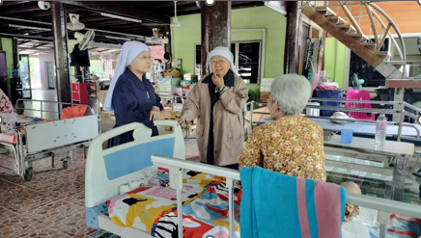

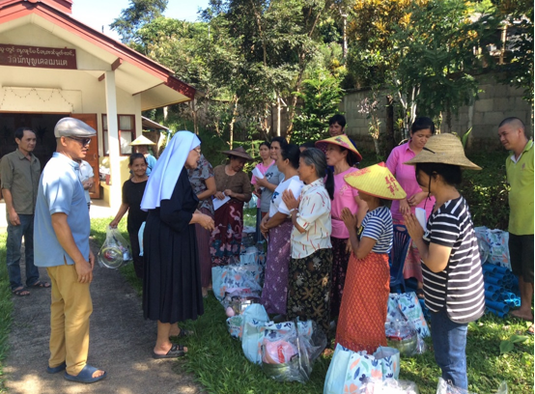
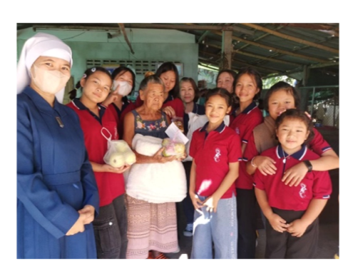
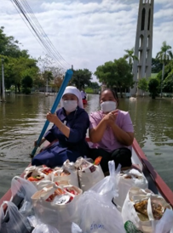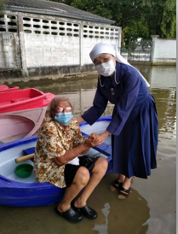

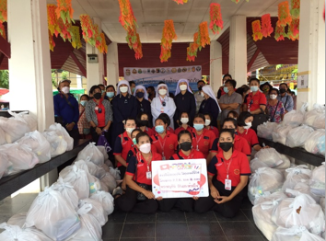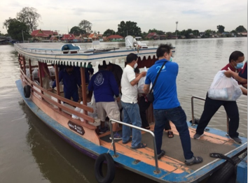

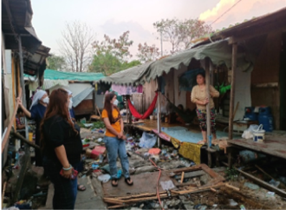

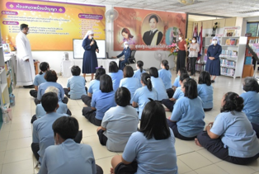

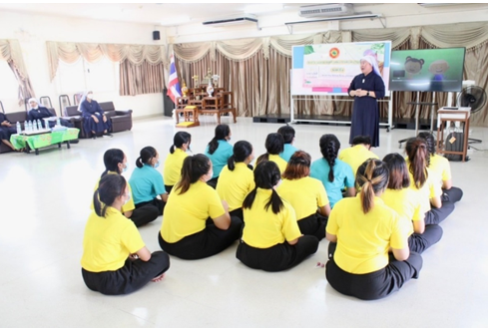

The Congregation also responds to disasters such as floods, fires, and the COVID-19 pandemic through the distribution of food, essential supplies, and emotional and spiritual support.
Listening to the cry of the poor teaches us that authentic love is not simply pity, but walking together with others, sharing generously, and restoring dignity to every human person.

3. Ecological Economics
Laudato Si’ reminds the world that an economic system focused solely on profit without concern for humanity and the environment creates inequality and destroys our common home.
The Congregation therefore promotes a simple, sufficient, and socially responsible way of life through the wise use of resources, reducing unnecessary consumption, and supporting initiatives that improve the quality of life for the disadvantaged.

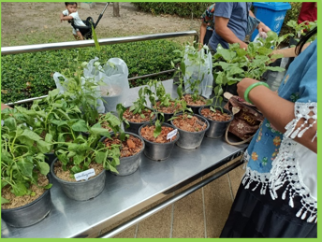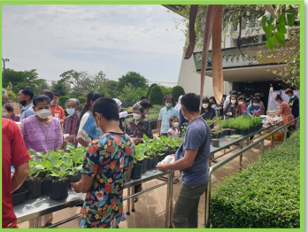
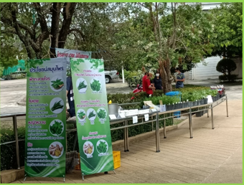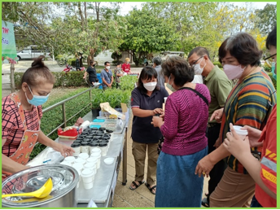

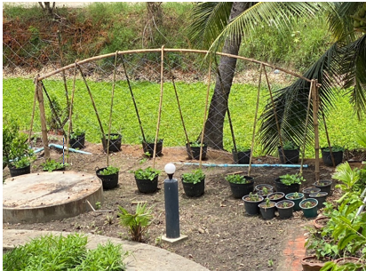
Organic gardening, bio-fertilizer production, the practice of the 7Rs, and the development of self-sufficiency learning centers are signs of the effort to create an “economy of care” rather than an “economy of consumption.”
The Congregation believes that using resources ethically is a way of honoring God, humanity, and nature.

4. Adoption of Sustainable Lifestyles
Members of the Congregation are invited to live with simplicity, humility, and responsibility in both personal and communal life.
Reducing plastic use, separating waste, conserving energy, planting trees, and caring for the environment in homes and schools are practical expressions of an inner ecological conversion.
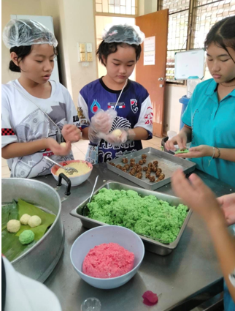

Laudato Si’ teaches that changing the world begins with small changes in daily living because every action affects others and the earth itself.
Thus, a sustainable lifestyle is not about deprivation, but about choosing to live with freedom, joy, and responsibility toward our common home.

5. Ecological Education
The Congregation recognizes that ecological awareness must begin with education, especially among children and youth.
Schools and centers under the care of the Congregation promote environmental learning through activities such as Environment Day celebrations, study of Laudato Si’ and Laudate Deum, practical environmental conservation activities, and the formation of young leaders who care for the earth.

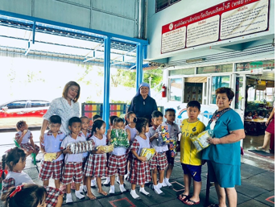
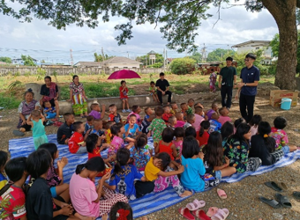

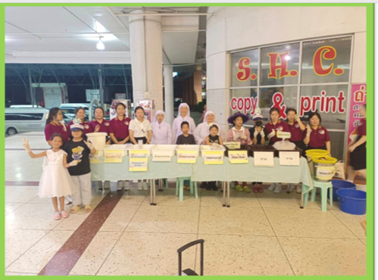

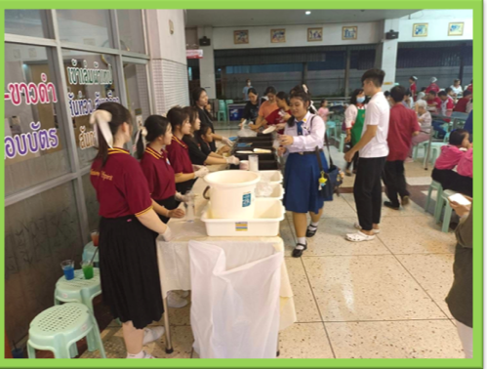
Beyond academic knowledge, the Congregation seeks to cultivate moral values, responsibility, and a spirit of care for creation so that children and youth may grow into people of love and service.
Ecological education is therefore not only about learning about nature, but also about building a “culture of care and shared responsibility.”

6. Ecological Spirituality
At the heart of Laudato Si’ is the call to renew our relationship with God, humanity, and creation through love and gratitude.
The Sisters strive to live their prayer life and mission with a spirituality that respects life, values every creature, and recognizes all things as gifts from God.

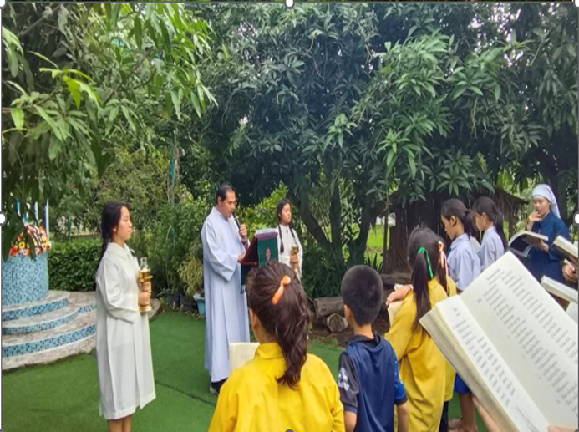
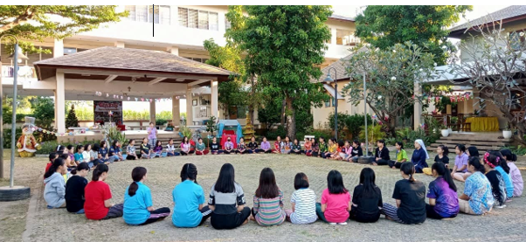
Prayer services for creation, celebrations of the Season of Creation, and reflection on the Word of God through daily experiences help members grow as “protectors of creation” following the example of Jesus.
When we look at the world with the eyes of faith, we discover that nature is not merely a resource, but a place where God is present.

7. Community Resilience and Empowerment
The Congregation realizes that caring for our common home cannot be done alone, but requires cooperation from all sectors of society.
The Sisters collaborate with many networks at the Church, social, and interreligious levels, including Caritas Thailand, the Federation of Religious Men and Women of Thailand, programs against human trafficking, child protection initiatives, and community development activities.

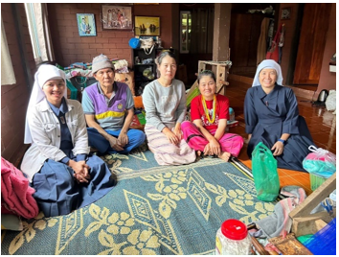

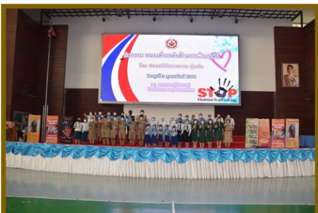
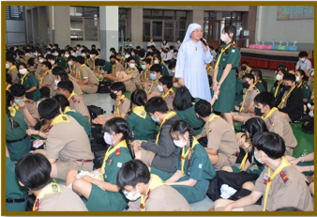

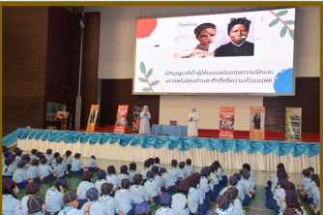

Working together with local communities, children, youth, families, and ethnic groups strengthens solidarity and helps create a more hopeful and resilient society.
Laudato Si’ reminds us that “everything is connected.” Therefore, building a new world begins with building good relationships and working together for the common good.

Conclusion
The life and mission of the Sisters of the Sacred Heart of Jesus of Bangkok, inspired by Laudato Si’, are a response to God’s call in today’s world through caring for creation, standing beside the poor, promoting human dignity, and fostering a culture of love and hope.
Although the world is filled with challenges and rapid changes, the Congregation continues to believe that:
“Small acts of love done with a sincere heart can transform the world.”
May the spirituality of the Sacred Heart and the teachings of Laudato Si’ continue to guide us in building a world that is beautiful, just, and filled with peace for all.

