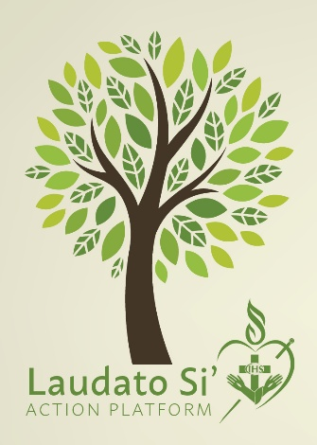
The commitment of the Felician Sisters of North America to the Laudat Si’ Action Platform (LSAP) calls us to interior conversion, education on issues, and to addressing our choices.
At the completion of Year 2, we sent a survey, with questions based on our action statements, to the sisters, associates and employees. We received 278 responses.
Overall, there was growth in the awareness of the need to care for the Earth. Comments in areas such as, including the Earth in prayer, visiting educational websites, and contacting legislatures, stated that while the respondents were not currently participating in these actions, they intended to start. There was also an increase in examining attitudes towards people different from us. This is encouraging especially during these tense times.
It was disappointing to learn that the purchasing of bottled water is still prevalent with 31% of respondents either not using a refillable bottle, found the question not applicable or did not respond. Health or water quality issues were noted, which is understandable for requiring water bottle purchases.
There was also a sharp decrease in the effort to eat meatless once a week. Our food choices have a direct effect on the environment, livestock, farm workers, and meat-processing plant workers. We are planning a webinar to provide education on this issue.
During Year 2, we provided opportunities for education and awareness raising through newsletters, social media, and our website. We also held a webinar highlighting all the actions being taken to address LSAP by our sisters, associates, employees, and sponsored ministries. Brochures with the action plan are available at ministry sites.
Together, we are making progress in our efforts to care for the Earth and celebrate our efforts!
The graph on the next page compares our progress from Year 1 to Year 2:

