
 |  | Cosmology Corner
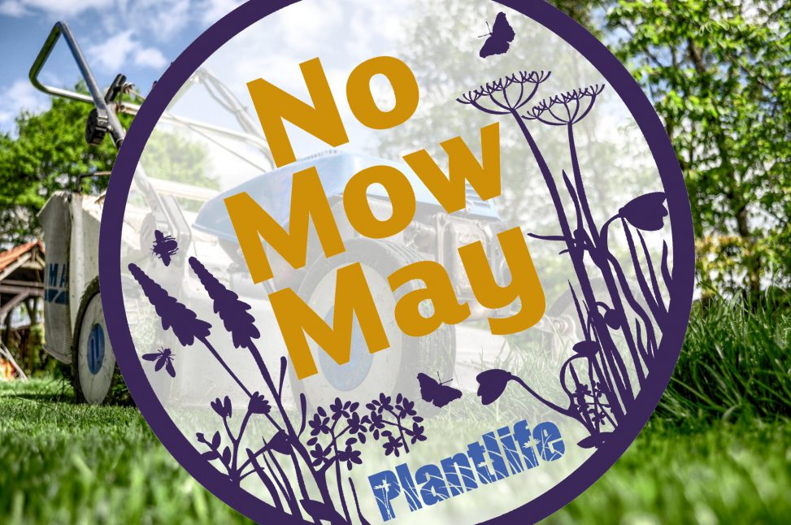  “If you struggle dealing with long grass, even a reduction in mowing to once a month throughout the summer can boost lawn biodiversity.” Sarah Shuttleworth – Botanist, Plantlife |  |  |  | No Mow May….  This is a time to turn our attention to conserving the richness of the grass on our lawns so that we can support wildlife, particularly pollinators and thus promote biodiversity.  The initiative of ‘No Mow May’ was introduced by  the charity, Plantlife in 2019 urging us to leave lawns for the entire month of May. This measure will ensure that insects, such as bees, butterflies and other pollinators will have vital food and habitat. We have had a continual loss of flower-rich areas in the last  few decades, so, be aware that long grass improves soil health, locks away carbon and provides natural cooling for the environment.  It’s time to recognise that wildflowers are good for our environment. Nicola Hutchison, director of conservation at Plantlife, said, ‘It is time to rethink wildflowers- they are not weeds, they are unsung heroes of the natural world’.  I won’t quote from Laudato Sí as we have done so many times- sufficient to say it throws light on the  aims of Plantlife initiative. Parishes around the  country have honoured the call to protect insects and allow pollinators to enjoy patches where they have food and habitat in one space. Perhaps our communities could commit to allow a patch of wilding so that we too can assist in sustaining biodiversity. Neat lawns do nothing for the environment, but we have not learned this yet as a province in the majority of our communities.  We do not do the gardening, so I have no doubt those who do this task will hear us if requested to leave an area for wilding throughout the year, not just in the month of May! www.forestryjournal.co.uk
 | “You may not have acres to play with in your garden but even a small patch of wildflowers can support dozens of bees, which means it will still have an impact, if you have a designated ‘wild zone’, this is a year-round commitment to the wildlife nearby, rather than just a few weeks.” Chris McIlroy www.plantlife.org
