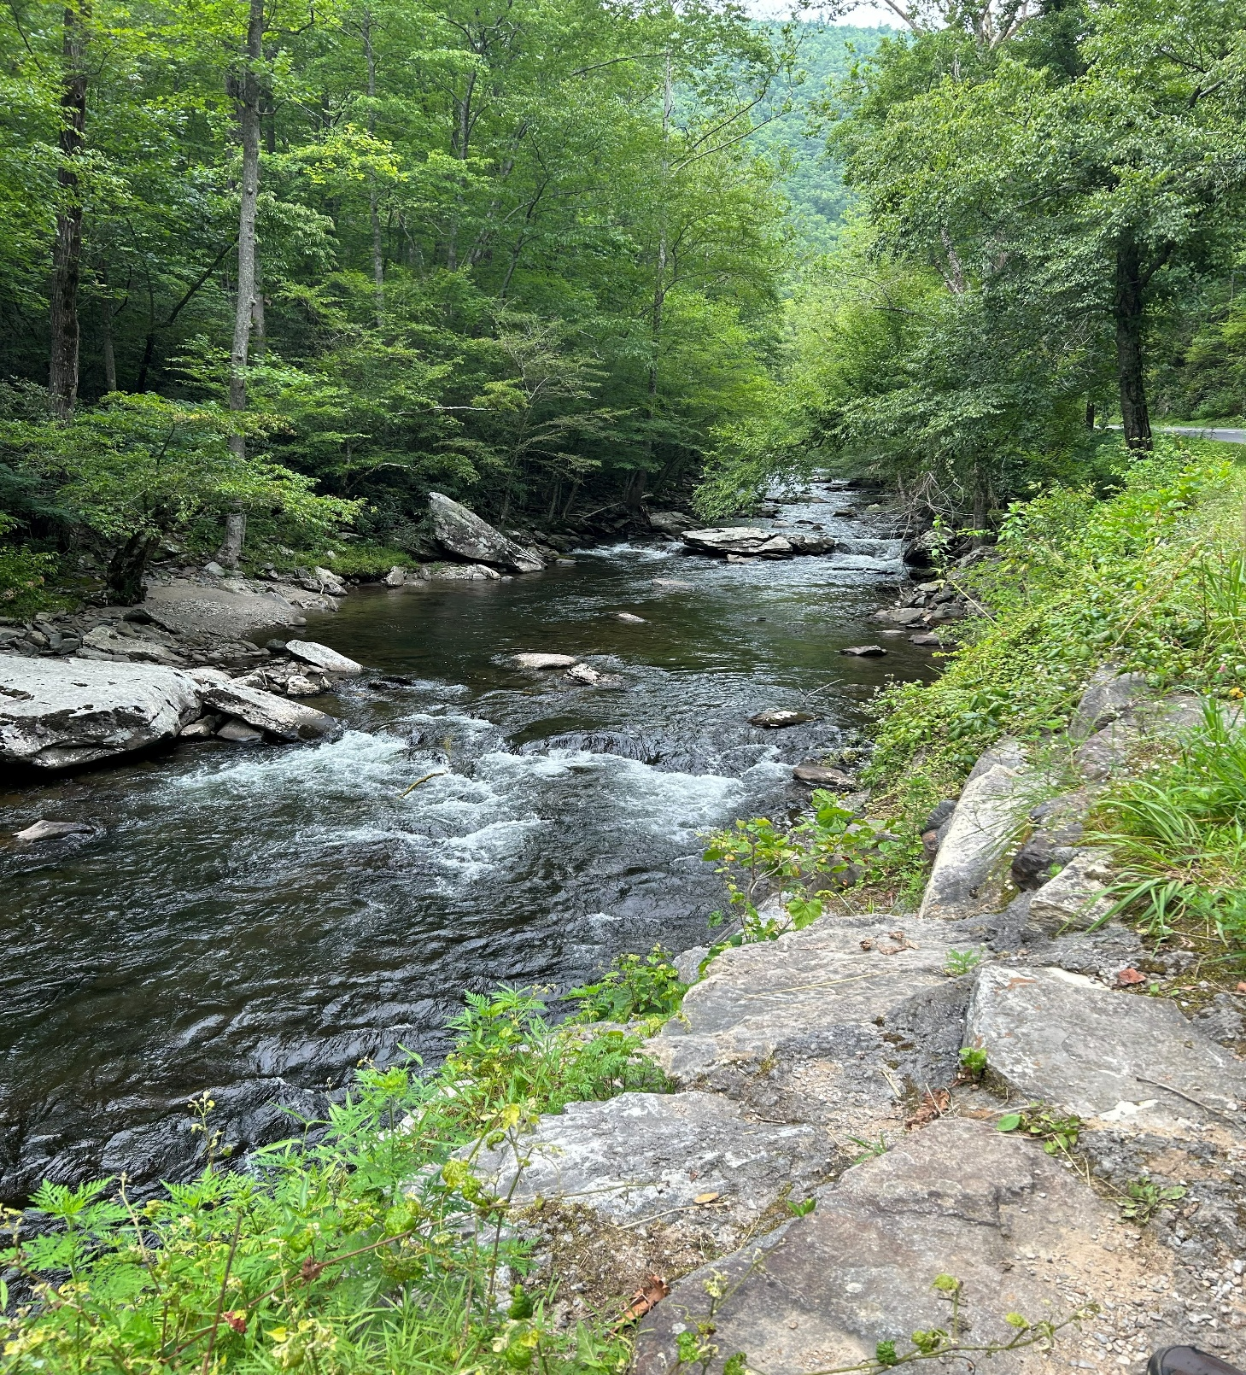
Dana Carroll, St. Louis, Missouri U.S.A.
2026

Ecological Conversion —a personal and communal journey rooted in faith, humility, and hope using the wisdom and inspiration of Laudato Si

I began the exercise of growing spiritually and an ecological conversion through my work with our parish’s Care of Creation Ministry. It started as a group meeting around specific issues of ecology, care of the poor and JustFaith. After some time, the focus was honed to a more targeted and guided approach, and it went from a group meeting at church to a ministry of the parish.

But what about a conversion? How do I approach this to more solidly anchor ideas, goals, training sessions and good intentions into a spiritual awakening, an ecological conversion? The Laudato Si Action Platform suggests I should:
- Recognize the spiritual and moral dimensions of the ecological crisis
- Embrace a lifestyle of simplicity, care, and solidarity
- Act with love and urgency to protect our common home and the most vulnerable.

To this end, I began by examining each of the seven sectors of Laudato Si. Then, I reviewed suggested action items to begin the conversion. Finally, I have started a Multi-year Plan with Laudato Si Action Items, Timelines and Steps. Now, the hard work begins.

Although I feel strongly about most of the seven goals outlined in Laudato Si, the feelings are somewhat distinct. I want to make a personal difference and make it sooner rather than later; however, some goals will challenge my conversion, and will require more prayer and deeper reflection, and most assuredly will only be achieved through divine intervention.
Response to the Cry of the Earth—I have adopted renewable energies and energy sufficiency measures. I will continue to monitor my carbon footprint and work toward achieving carbon neutrality. I own a farm along with my family and will continue to find ways to promote sustainable agriculture. I will explore ways to reduce my own water consumption and attempt to ensure that all people are able to access clean water.
Response to the Cry of the Poor—This goal strikes my heart with the most urgency and gravity-I guess because of my work with marginalized populations. I will participate in St. Vincent de Paul, as we already support the work of two chapters, one at our former parish in Springfield, MO and one in St. Louis, MO in our home parish.
Ecological Economics—This goal seems rather achievable on the one hand, and moving toward a more sustainable lifestyle will be challenging but done without resistance on my part. The goal of protecting the dignity of workers will be challenging, as I live in a large city and some shopping sites will be harder to track down than others, but I am certainly committed to working toward supporting circular economies and fair wages.
Adoption of Sustainable Lifestyles—I believe this goal connects with Ecological Economics. It will require that I become more informed about where items are being manufactured, as well as attempt to grow even more items myself. When moving toward becoming vegan, that will not be as easy, nor will it come without some hesitation. This will certainly be tougher to get any members of my family to go along with this part of the goal. We are rethinking how we purchase items such as beef and chicken. I am committed to reducing waste by avoiding single-use items, recycling and using public transportation when available, as well as walking and cycling when possible.
Ecological Education—Because of my work in the education arena, this goal resonates with me. If we are to achieve any real and lasting change, it will require a commitment to engaging young people on a level where they will accept ownership of the issue.
Ecological Spirituality—Engaging Catholics in a meaningful way should include more than an economic reason. Catholics will be moved to make sacrificial and/or lasting change, helping them see the tie to our spiritual lives is necessary.
Community Resilience and Empowerment—It seems to me that connection within our communities allows for a more immediate and beneficial change. It will be important to empower people to make decisions for themselves.

Dana Carroll’s LAUDATO SI PLAN GOALS—2026
Goal |  | Date | Comments
Response to the Cry of the Earth
 | Explore More Solar Panels | 8-15-26
 | Add Insulation | 10-1-26
 | Plant Native Trees on Farm | 11-15-26
 | Garden Work | 5-20-26
 | Explore Pollinators | 5-15-26
 | Protect Pollinators | 6-1-26
 | Trash Clean-up | 10-15-26
Response to the Cry of the Poor
 | Participate in Pro-Life Demonstrations | 1-21-26
 | Volunteer at Project Rachel | 7-1-26
 | Volunteer at St. Vincent de Paul | 5-11-26
 | Donate to St. Vincent de Paul | monthly
Ecological Economics
 | Practice Gift Economy | Ongoing
 | Recognize and Support “Care Labor” Careers | 5-1--26
 | Shop Local | Ongoing
Adoption of Sustainable Lifestyle
 | Add No-Meat Mondays to Menus | 5-1-26
 | Recycle | Ongoing
 | Composting | Ongoing
 | Rain Barrel | 3-1-26
 | Install More Efficient Lighting | 5-26-26
 | Buy Food From Local Producers | Ongoing
Community Resilience and Empowerment
 | Pursue Environmental Policy | 9-15-26
 | Advocate on Policy | 12-1-26
 | Ensure Buildings Prepared for Seasonal Change | 9-20-26
 | Checklist for Energy Efficiency at Home | 8-1-26
 | Checklist for Energy Efficiency at Church | 8-15-27
Ecological Education
 | Study the Local Ecosystem at Botanical Garden | 6-15-26
 | Develop a Training on Laudato Si Planning | 6-1-26
Ecological Spirituality
 | Plan a Season of Creation Event | 6-20-26
 | Hold a Synod Session Season of Creation Event | 9-1-26
 | Establish a Season of Creation Ritual | 9-1-26
 | Establish an Outdoor Prayer Garden | 7-20-26
 | Develop a Prayer Walk Plan | 9-30-26

