As we celebrate the 11th anniversary of Laudato Si’, the FCJ Centre continues to reflect on how we are called to care for our common home through both ecological awareness and community connection. Inspired by Pope Francis’ reminder that “everything is interconnected,” we are seeking ways to nurture the relationship between people, the Earth, and God through meaningful and practical initiatives.
One area of growth for us has been the development of community garden beds and seniors gardening programs. These spaces are more than gardens; they are places of encounter, learning, and belonging. They offer opportunities for seniors and community members to gather, share knowledge, cultivate food and flowers, and reconnect with the healing rhythms of nature. Gardening encourages mindfulness, gratitude, and stewardship while also strengthening community relationships across generations. Through these programs, we witness how caring for the Earth can also care for the human spirit.
We are also exploring workshops focused on energy efficiency and sustainable living practices. These workshops aim to help participants better understand how small changes in daily life can reduce environmental impact while supporting responsible use of resources. By encouraging practical actions such as conserving energy, reducing waste, and making thoughtful choices, we hope to empower our community to live more sustainably and consciously.
These initiatives build upon the FCJ Centre’s ongoing commitment to ecological conversion through actions such as reducing plastic use, improving recycling and composting practices, using eco-friendly products, and creating spaces for prayer and reflection rooted in creation spirituality. Together, these efforts reflect our desire to embody the message of Laudato Si’ not only through words, but through concrete actions that foster hope, compassion, and care for creation.
As we continue this journey, we remain grateful for the invitation to walk gently on the Earth and to deepen our awareness that caring for creation is both a spiritual responsibility and a shared act of love for future generations.

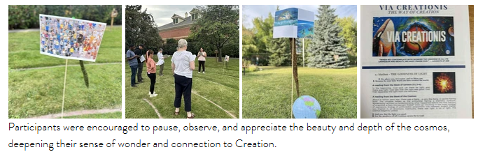
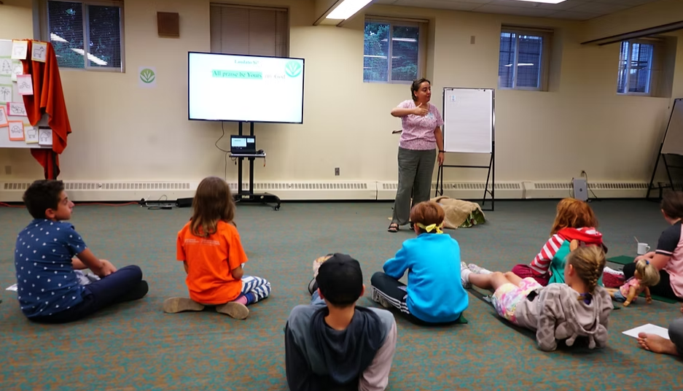
Vacation Bible School – Four Elements: Fire, Water, Wind, Earth

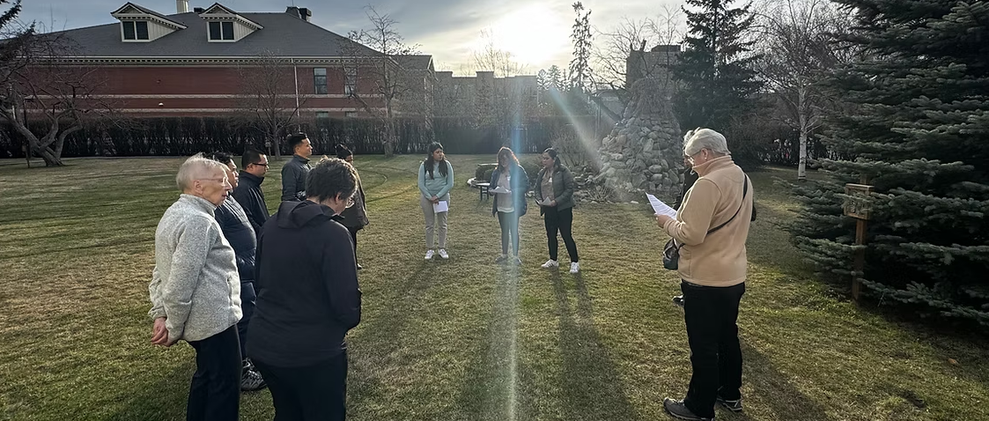
Earth Day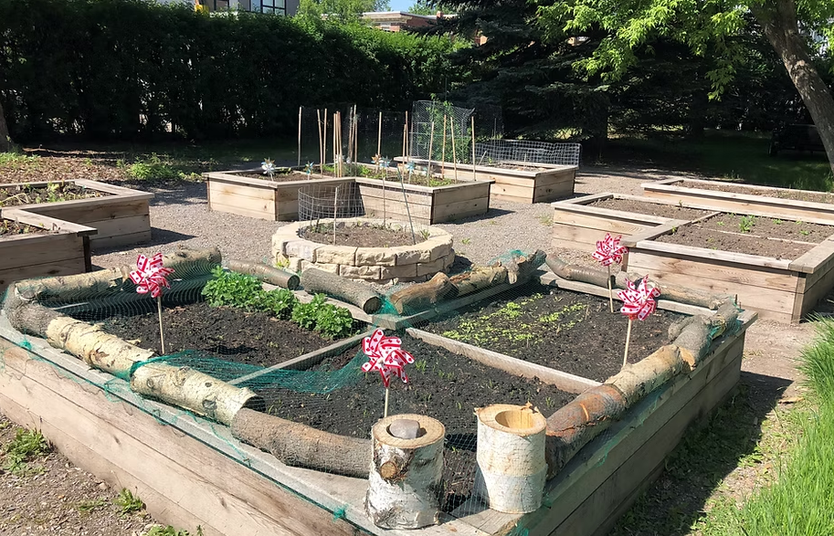
Community Garden Beds
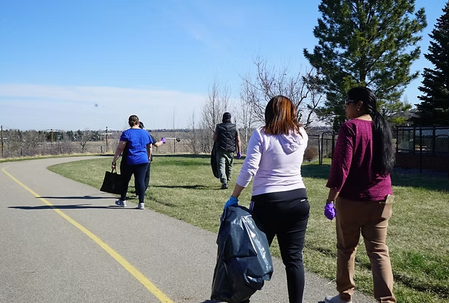
City’s River and Pathway CleanUP

