“All of us can cooperate as instruments of God for the care of creation, each according to his or her own culture, experience, involvements and talents.” LS14
Based on the policy of the 2020 General Chapter and in response to the call of the encyclical Laudato Si’, the congregation has continuously carried out environmental initiatives. These efforts promote awareness among members and personnel regarding the conservation of nature through learning, practical actions, and prayer. Children, youth, and members of the congregation are encouraged to recognize the value of creation and to actively participate in caring for the environment through various activities such as tree planting, waste separation, composting, and living according to the sufficiency economy philosophy.
Each local community where members reside is encouraged to implement environmental projects, including carbon reduction, proper waste management, chemical-free home gardening, and the development of learning centers based on the sufficiency economy way of life. These initiatives provide opportunities for all to learn a lifestyle that respects nature, reflecting a spirit of appreciation and gratitude to the Creator. Additionally, the “Sacred Heart for the Earth” project, inspired by the Laudato Si’ document, has been implemented in all communities where members serve during the years 2024–2025.

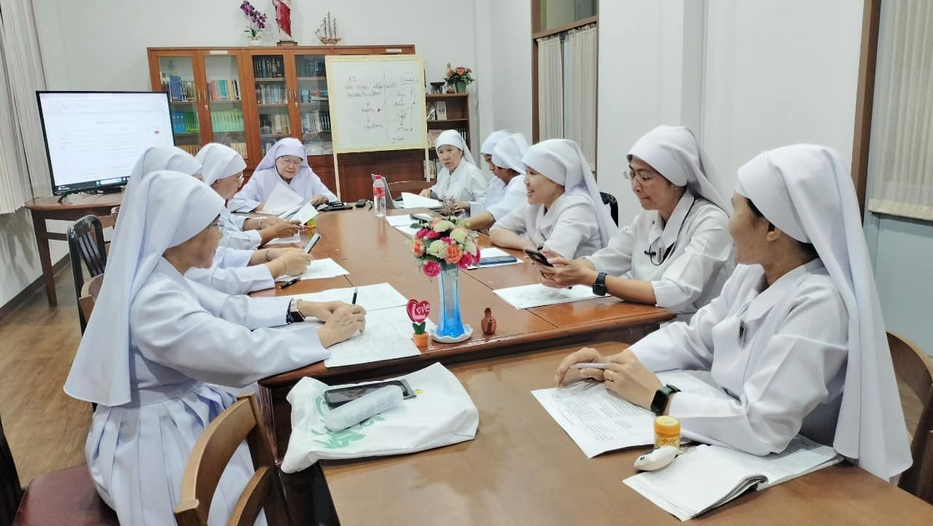

Outcomes:
Several schools have received outstanding environmental awards at national and diocesan levels, including both schools under the congregation and those administered by members within dioceses.
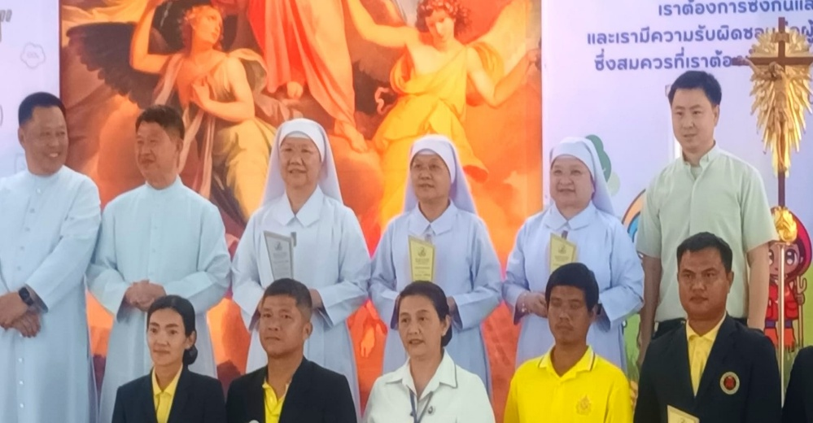
All communities with resident members have participated in the “Sacred Heart for the Earth” project in line with the Laudato Si’ encyclical and have implemented agreed actions at the community, regional, and congregational levels.

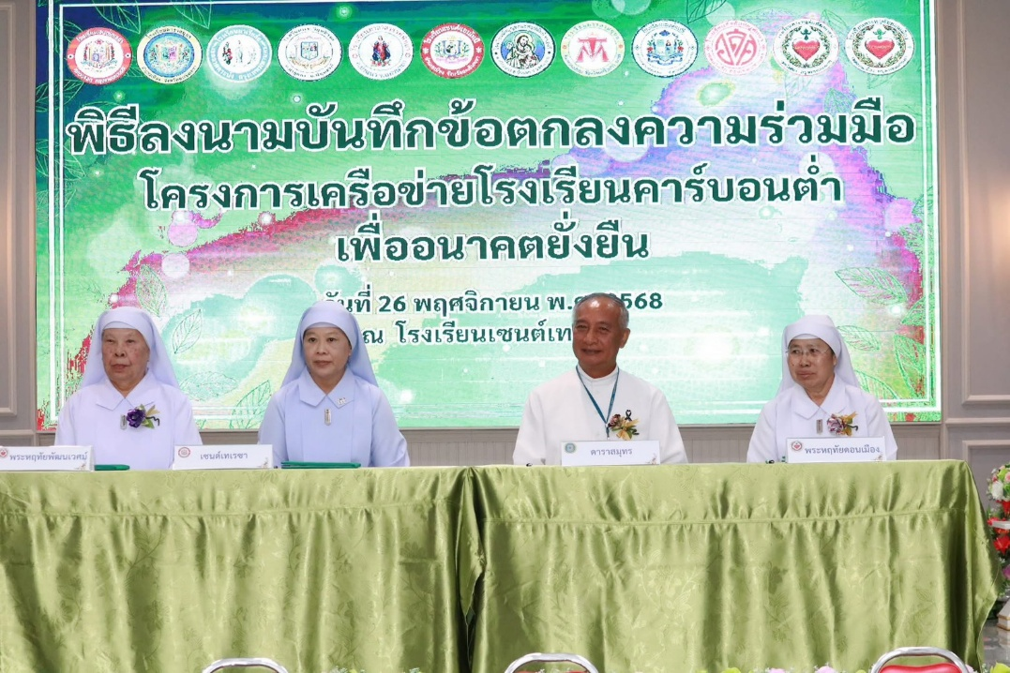

Continuous campaigns have been carried out on waste separation, tree planting, and landscape improvement in communities and schools.
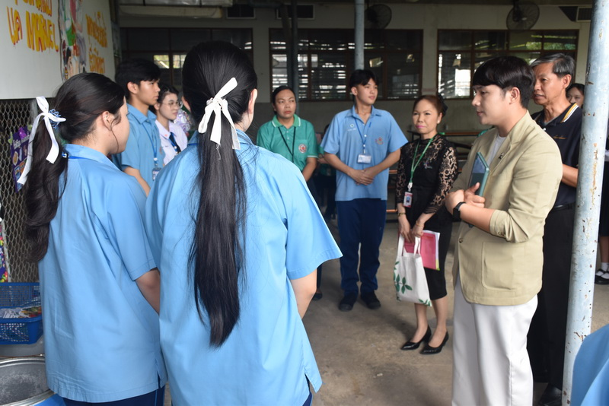

Children and youth actively participate in environmental learning within their own schools and in collaboration with other schools.
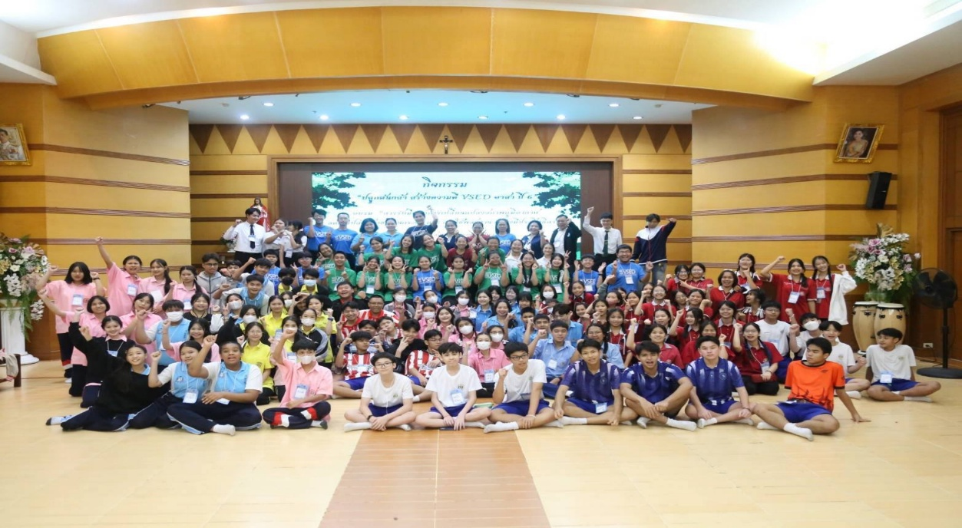
Environmental education based on Laudato Si’ and Laudate Deum has been provided through activities such as “Uniting for Our Common Home” for novices, children, and youth.

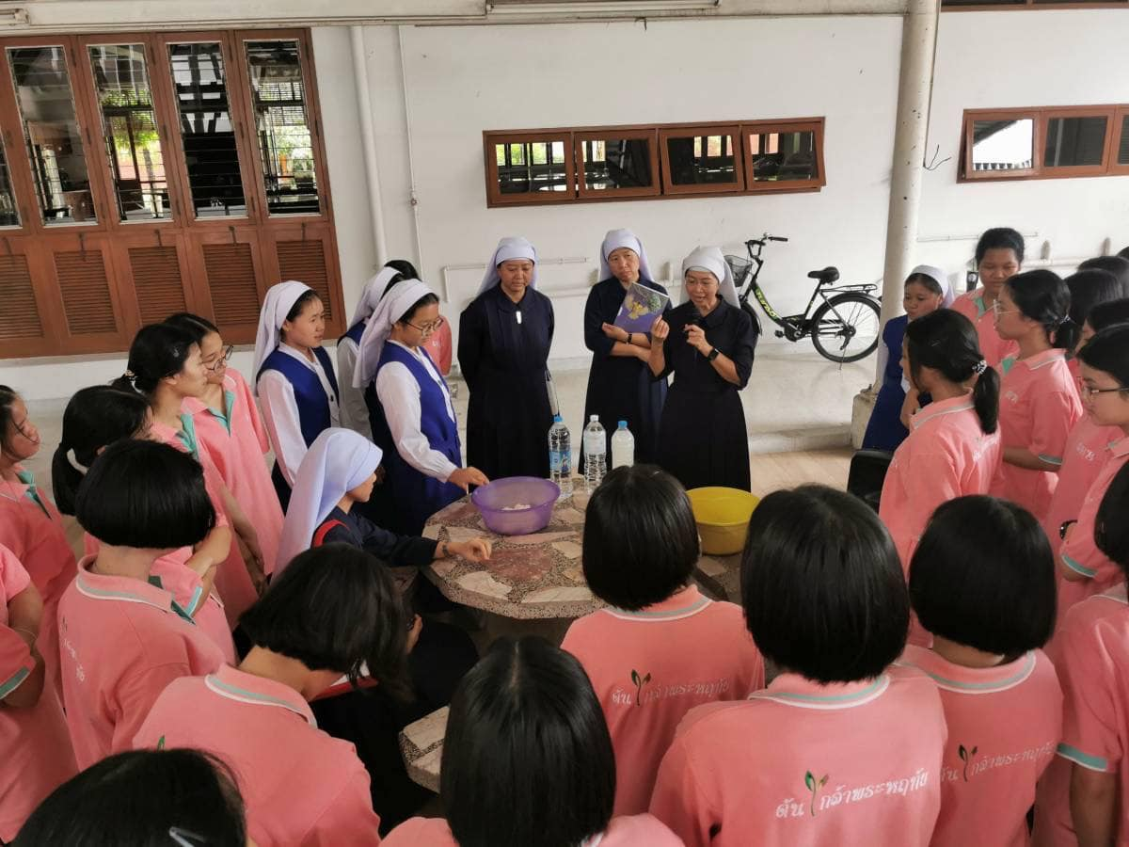
Environmental Day and the Season of Creation have been regularly observed in response to the call of Pope Francis.
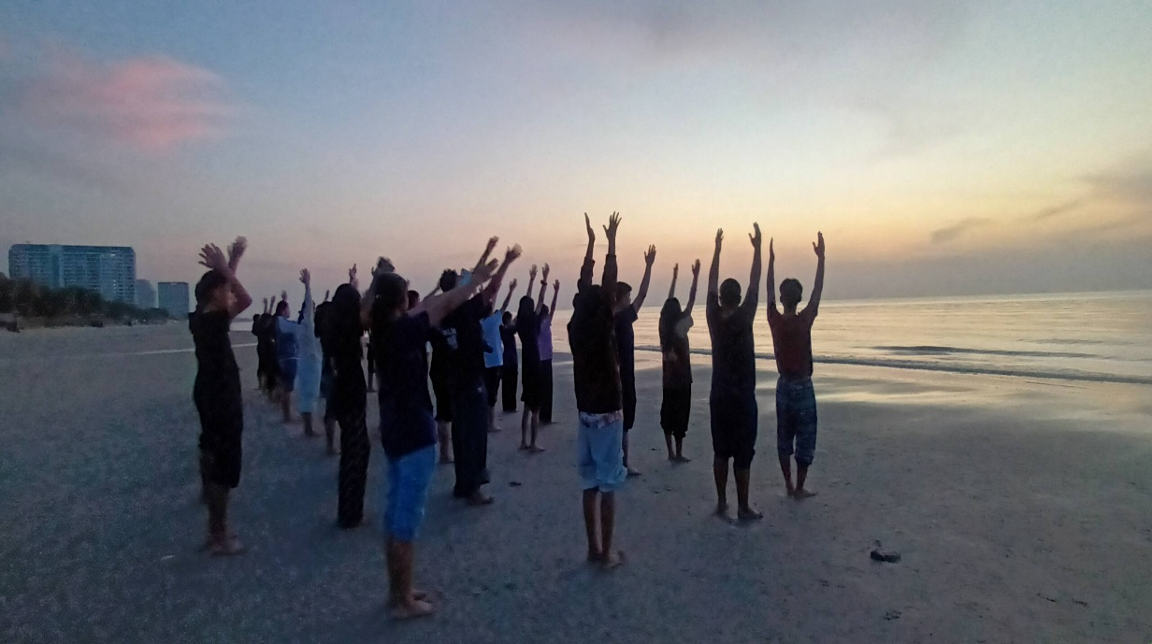
Development of sufficiency economy learning centers has taken place in various locations, such as Saint Roch Church, Ban Suan Damnoen Saduak (composting, vegetable gardening, bio-extract production), Ban Suan Lampang, Sawankhalok, and five schools of the congregation, among others.

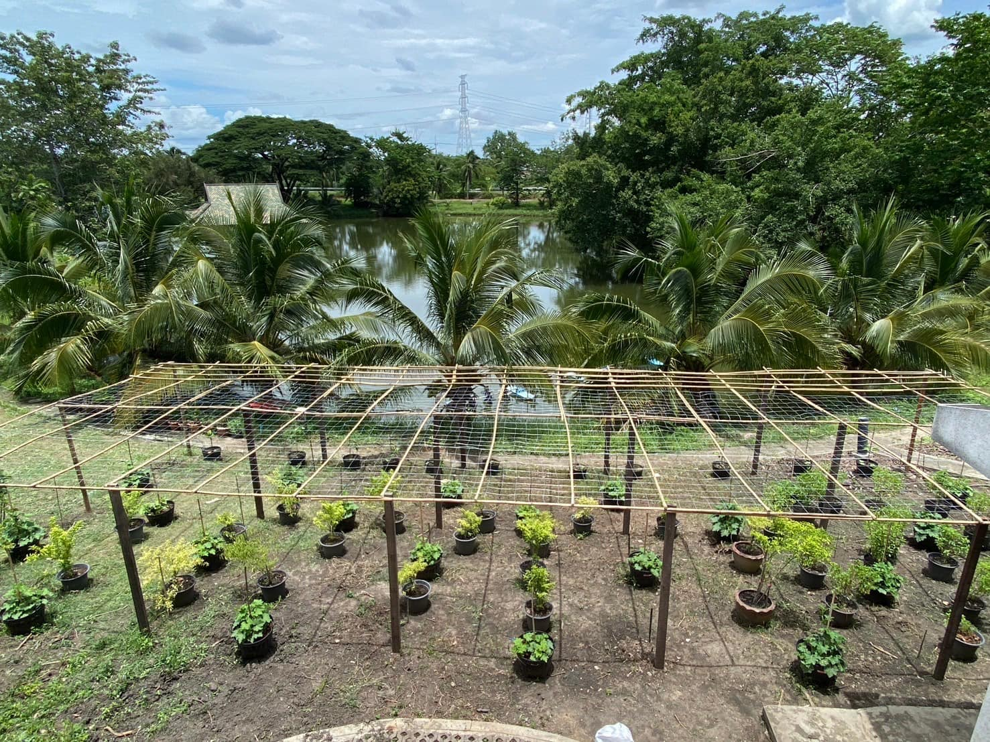
The principles of the 7 Rs (Reduce, Recycle, Reuse, Refuse, Repair, Refill, Return) have been applied in daily life.
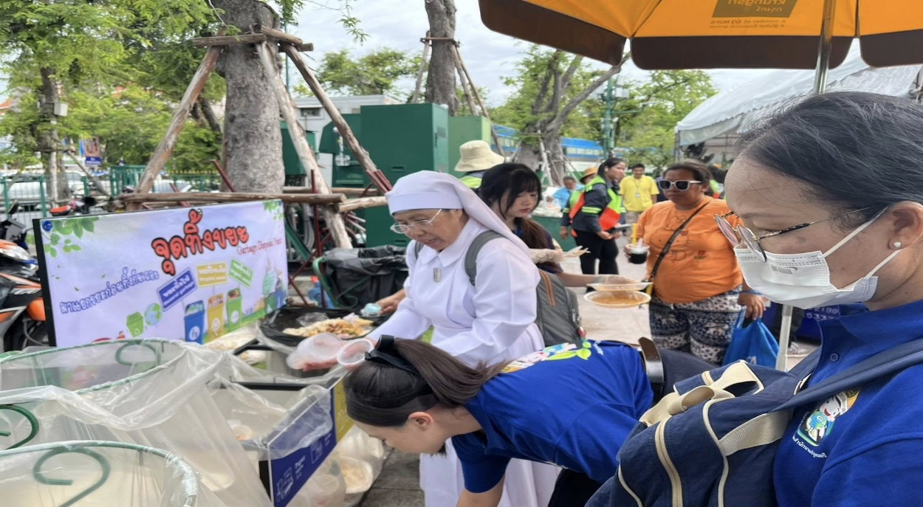
Assistance has been provided to the poor and underprivileged both within the congregation’s schools and in surrounding communities.
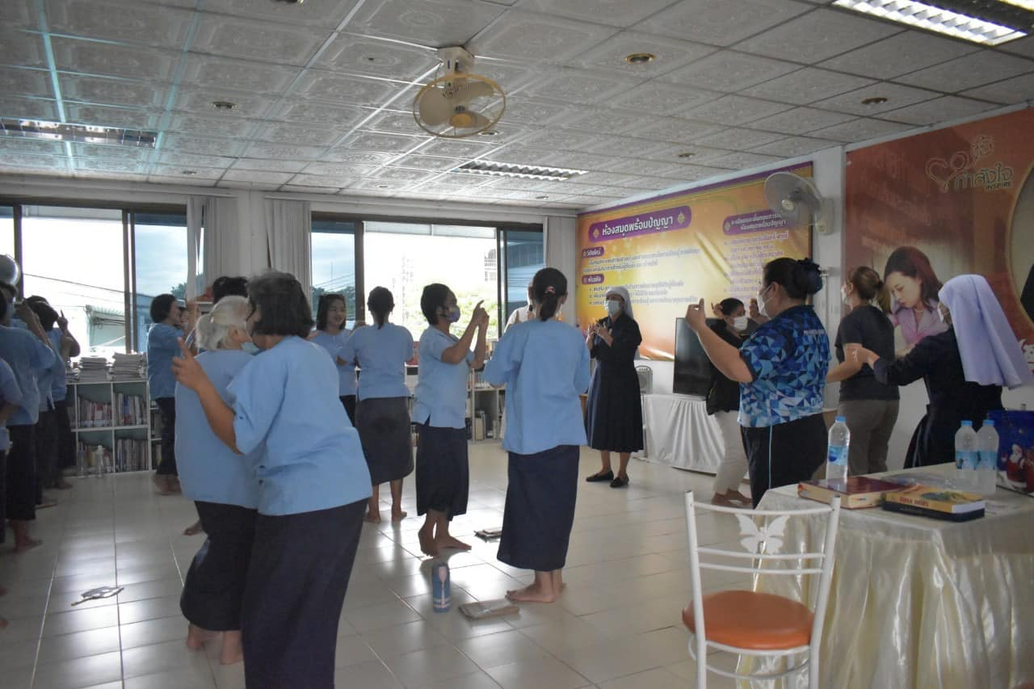

In summary, the Sisters of the Sacred Heart have worked together in unity to follow the guidance of the encyclical Laudato Si’ in caring for our common home, the Earth, in every community where we live. We also strive to extend this cooperation to surrounding communities, fellow believers, government sectors, and private organizations. This mission is ongoing and not yet complete.
With the help of God the Father, who has entrusted this world to humanity, we will continue to cultivate habits and behaviors that care for our common home among those around us—children, youth, staff, the faithful, and the Sisters themselves. We aim to foster love for one another and for all creation, both living and non-living, which will lead to a deeper love for God the Father, who has given this beautiful world to all of us, with hearts full of gratitude for His love.

Picture 1 the intentions of sisters for practice of Laudato si
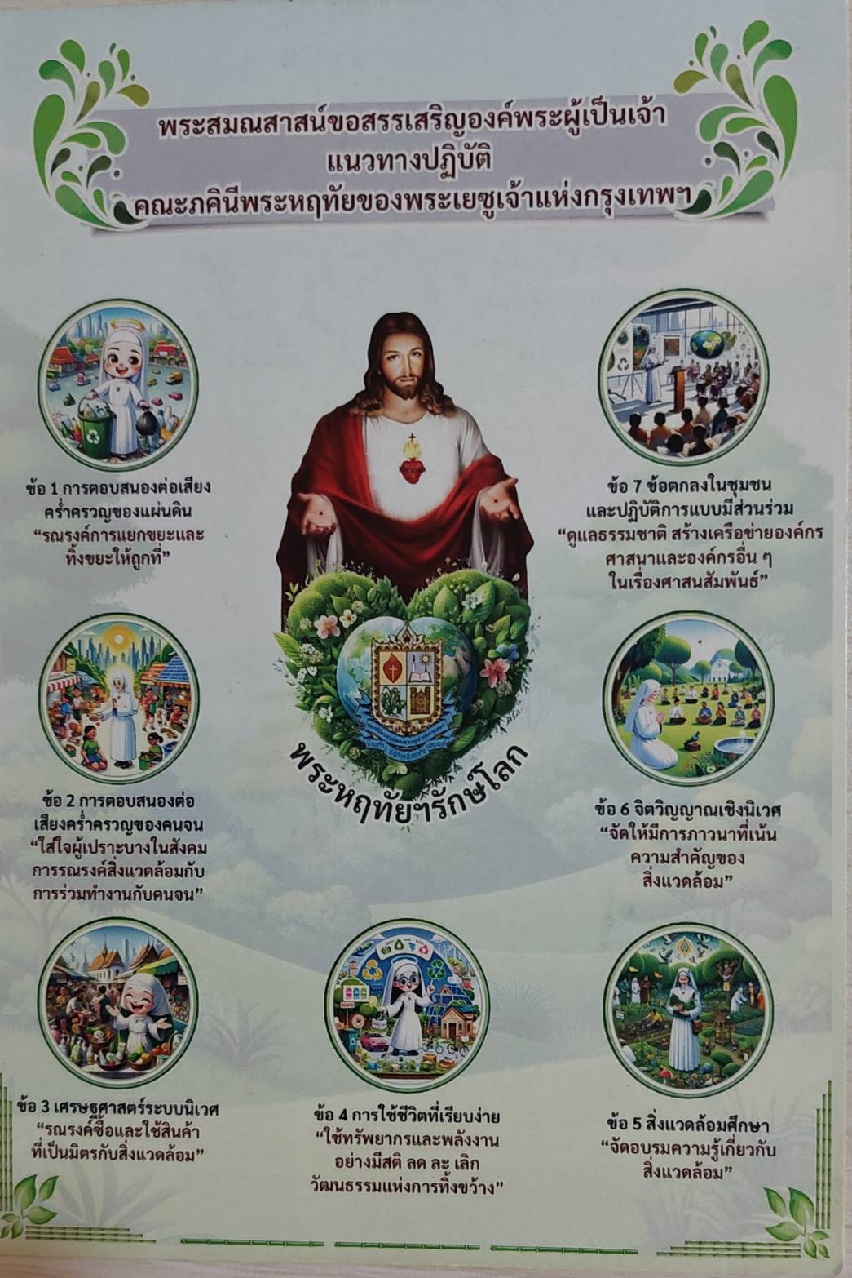
Picture 2 the prayer for creation
