**“A Visible Presence”**

**Laudato Si’ Action Platform Reflection**

**Church of the Resurrection, Dubuque, IA**

**October 2024**

The Church of the Resurrection has completed its second year as part of the Laudato Si’ Action Platform. Several of our goals have been met and good progress is being made on several more. Using the seven goals of the Laudato Si’ Action Platform, we offer this reflection on the past year and celebrate our achievements.

**Adoption of a Sustainable Lifestyle**

This year we have renamed our Environmental Stewardship Committee or Green Team to the Creation Care Team. This better reflects Catholic Social Teaching and Pope Francis’ statement in “Laudate Deum” that “Once and for all, let us put an end to the irresponsible derision that would present this issue as something purely ecological, ‘green”, romantic, frequently subject to ridicule by economic interests.” This name reflects not just our goal to be more sustainable in all parish activities, but to create a culture which recognizes that the lack of care for the Earth is a social and ethical issue which affects us all, particularly the most vulnerable. It also encourages individuals to develop a reverence for God’s loving gift of the natural world and our responsibility to protect it.

In February 2024, our Creation Care Team met formally for the first time since 2018! Informal gatherings continued throughout the year including two cleanup days along the street that runs adjacent to our church, and a meeting in June to review our sustainability plans for our annual parish festival. Our next meeting is scheduled for November 13th to generate ideas for the coming year.

Our team leader met in early February with the festival committee to discuss our goals for a more sustainable fall festival and improve on the shortcomings from last year. Our goal was to utilize compostable, recyclable, and reusable materials, and alleviate all Styrofoam and plastics. We continued to communicate throughout the spring and summer to find appropriate products. At festival time, we used reusable platters and silverware for those who ate in our dining room and compostable take-out containers for those who desired to carry out meals. In the past, Styrofoam containers were supplied by the catering company. As an alternative to single use plastic water bottles, we filled large five-gallon thermos containers with fresh ice water throughout the event. Our youth group was instrumental in keeping these containers filled. Comments from our guests indicated they preferred this fresh ice water to the bottled water. We did use plastic drink cups with the caveat that our contracted recycling company promised to recycle all the #2 cups used. The matter of cost always enters into the decision of what materials to order, but we will continue to advocate to use compostable products whenever possible because it is simply the right thing to do.

During Lent, we proposed a “plastic bag fast” to our parishioners. Posters were placed in the back of church, and it was announced in our weekly bulletin.

During the upcoming holiday season, we will again be recycling unused or burned-out Christmas lights.

**Community Resilience and Empowerment**

There are many members of our parish who work in partnership with local, city, state and federal organizations who are concerned about climate issues. Examples of local groups include the Dubuque Interfaith Green Coalition (the local chapter of Iowa Interfaith Power and Light,) and Dubuque Area Congregations United. This year, the city of Dubuque received a $50,000 grant from Bloomberg Philanthropies as part of its Youth Climate Action Fund. Dubuque was only one of 101 global cities chosen for this grant for work that spans over 38 countries across six continents. These grants were designed to inspire young people between the ages of 15-24 to develop, produce and implement urgent climate action in our community. Members of our parish educated the parish and the public about these grants and our Youth Group applied for a grant to make our public bathrooms more energy efficient. More grants are anticipated next year, and we will continue to promote these opportunities and encourage our young people to participate.

**Ecological Economics**

Our parish is moving forward on plans to install solar panels. Thus far, we have completed a solar assessment and have presented our plan to the city for approval. We continue to research financing options.

As noted above, maintaining and expanding our sustainability best practices continues to be a priority in all parish activities and events.

**Response to the Cry of the Earth**

The most exciting progress made this year was or plan to begin planting in the approximately eight-acre field behind our church and school. In April, 36 native trees were planted by our second-grade students, their parents and teachers thanks to a grant from the Iowa Department of Natural Resources (DNR) Trees for Kids program. The program included planting instructions from a DNR forester and a tree blessing by Deacon Mike Ellis. As you can see, the weather was not the best that day. but that did not dampen the spirits of these children.

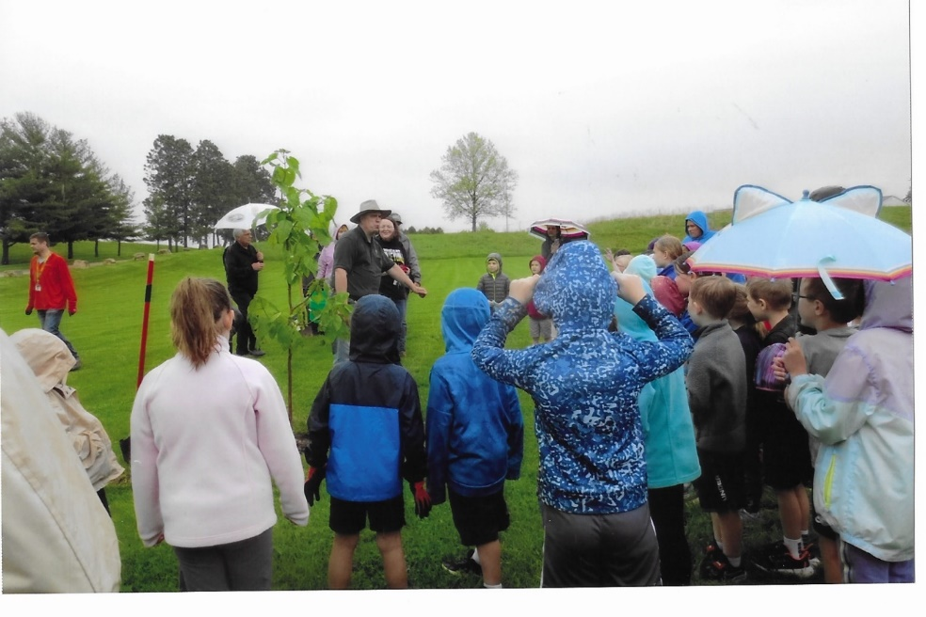

The children, parents and teachers continued to water these trees throughout the summer and continue to do so even now, as Iowa is currently experiencing a drought.

We are moving forward with our plans to turn the neglected 3-acre field at the back of our property into a restored prairie, complete with walking paths and areas for seating and quiet reflection. In July, our prairie restoration project came to the attention of the U.S. Fish and Wildlife Service (FSW.) One of their field biologists assessed the site and felt it was a potential habitat for the endangered rusty patch bumblebee, which has recently been spotted in our area. Under the direction of the FSW, we hope to begin site preparation this fall with hopes to seed the prairie in the spring of 2025.

In July, our Youth Group constructed two raised garden beds and were able to grow a small crop of vegetables. There are plans to construct more of these raised beds in the future in the hope that some of the vegetables could be included in our food pantry distributions.

In September, a parishioner came forward and asked to plant a “numbers garden” along one side of our old school building that was overgrown with weeds and thistles. She had designed this garden to exemplify the significance that certain numbers symbolize in our Catholic faith. For example, “one” symbolizes the oneness and unity of God. “Two” symbolizes the dual nature of Christ, both human and divine. “Three” symbolizes the Holy Trinity, and so forth. Appropriate plant plugs native to Iowa were chosen in coordination with these numbers such as columbines, wild geraniums, butterfly milkweed and purple coneflower. With the assistance of the Youth Group, a total of 70 plants were installed. This 148x4 foot area has been completely transformed and by spring, will serve as a place of beauty as well as an inspirational/educational asset to both the school and parish.

We are preparing to share our vision to all parishioners in the months ahead and in doing so have developed the following Vision Statement:

“As Christians and members of Resurrection Catholic Church, it is our responsibility to uphold God’s values, which encompass respect for all life, including the precious gift of the natural world. Recognizing that God deemed all of creation “very good” calls us to view nature with the same reverence. Therefore, we commit ourselves to do our part on these parish grounds to honor God’s love for us in gratitude for His abundant gifts. This commitment helps us to see ourselves as an integral part of God’s great design, embracing His love for the world and all who inhabit it.”

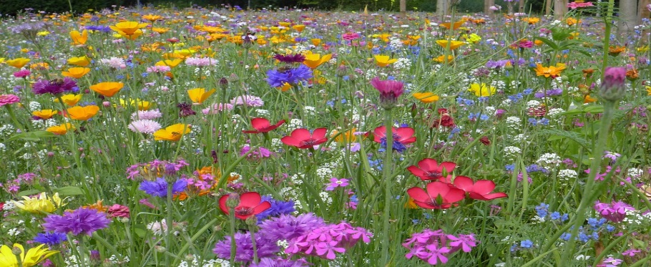

**Ecological Education**

In April, members of our parish, in collaboration with the Dubuque Interfaith Green Coalition, held a study of Pope Francis’ apostolic exhortation, “Laudate Deum.” Climate related meetings, activities, and general information have been posted on our Social Justice Facebook page throughout the year.

There were many activities scheduled within the community this year during the Season of Creation and several of our parish members were involved in planning some of these events. Our parishioners were advised of these activities and encouraged to attend. Some of these programs coincided with the International Day of Peace celebration in September.

As our parish moves forward with our Green Space Development project, our school leaders are coming forth with some wonderful ideas about how we can involve our grade school children in creation care activities. Some examples include planting native prairie seeds in the classroom, then transplanting and caring for them in a targeted plot on the periphery of the prairie. They have also talked about constructing a small raised bed garden and greenhouse close to the school to provide “hands on” activities for the children. These projects speak to our continuing goal to “involve our children in outdoor activities to teach an appreciation of the natural world and enhance their education and faith formation as it relates to Pope Francis’ encyclical, “Laudato Si’.” Once the prairie is established, we hope to develop that area further with bird and butterfly houses, story boards with applicable Bible verses, and other age appropriate activities the coincide with their school curriculum.

**Ecological Spirituality**

During the tree planting in April with our second graders, a tree blessing was performed by our Deacon Ellis. On October 4th, the feast of St. Francis of Assisi, Father Phil and Deacon Mike did a blessing of the animals for the pets of the school children and pets brought by other parishioners. We also closed out the Season of Creation with an evening prayer service. One of the most memorable activities during the Season of Creation was a Rural Life Mass organized by the Archdiocese of Dubuque. Several of our parishioners attended.

**Response to Cry of the Poor**

The Church of the Resurrection regularly hosts activities to respond to the cries of the poor in our community and globally. We hold food pantries four times a year, distributing between 110-150 boxes of food to the needy each time. Some of those served this year are individuals who are isolated because of long term disabilities. This year, an additional food distribution will also be done the week before Thanksgiving to substitute for a community Thanksgiving meal that had operated for many years but was forced to close. In recent collections taken during weekend masses, enough money was raised to cover the costs for all these activities for the coming year.

In October of last year, we hosted a pancake breakfast with First Baptist Church with all proceeds going to People in Need (PIN.) PIN provides monetary assistance to individuals and families in the community who are facing emergency situations affecting their health and safety, primarily to prevent shutoffs of necessary utilities and eviction due to the inability to pay rent.

In December of last year, our women’s group, Living in Faith Together (LIFT) sponsored a Vendor Fair with all proceeds going to a non-profit organization that helps women and children who are experiencing homelessness in our community.

Our parish continues to support our local St. Vincent de Paul Society through regular donations of food, paper products and personal items. We sponsor a giving tree during Christmas to provide food and gifts for needy families and nursing home residents. Groups within the parish continue to plan and serve meals at the Dubuque Rescue Mission on a quarterly basis. We also continue to support our Partner Parish in Wamblee, South Dakota. In addition, we provide periodic monetary donations for relief services provided by Catholic Charities and other global relief agencies, most recently to the refugees in Gaza and the victims of the hurricanes in the southeast United States.

Catholic Relief Services (CRS) are just beginning to establish a chapter here in Eastern Iowa at the request of the Archdiocese of Dubuque. As part of our involvement, we are advocating our legislators to draft and approve a new Farm Bill that will protect international food assistance programs and will be fair and equitable for all.

In conclusion, the Church of the Resurrection has made progress in responding to all the calls to action proposed by the Laudato Si’ Action Plans. We are proud of these accomplishments and our efforts to be a visible presence in our community. But what we are most proud of is the progress we have made in developing a green space for our parish. What began as a mere idea of what could be possible, is beginning to flourish and our hope is that parishioners of all ages will utilize this space to reflect on the wonderful gift of creation God has given us. Unfortunately, It is something most people take for granted. We continue to face challenges in designing ways to educate people on the importance of heeding the calls for climate action. In Laudato Si’, Pope Francis states, “All Christian communities have an important role to play in ecological education. Our efforts at education will be inadequate and ineffectual unless we strive to promote a new way of thinking about human beings, life, society, and our relationship to nature.”

We also need to bring people outdoors and immerse them in the natural world. Pope Francis speaks about this “intimate connection” (234) as a way to find God in ordinary things. In this time of social and political chaos and division, perhaps nature can provide the healing we all so desperately need.