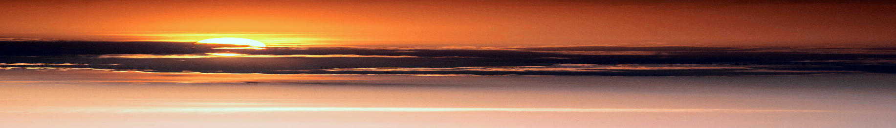

**NEW IDEAS for NEW NEEDS**

O

n the 24th of May 2015, Pope Francis launched his encyclical *Laudato Sí*, and thereby gave the official Church both a new spirituality and a new moral teaching. For most of the two-thousand-year history of the Christian faith, moral teaching was focused on human relationships with God and other human beings. The abuse of nature was not considered as wrong-doing. Incorrect interpretations of the Genesis account of creation led to the unrestrained exploitation of nature. Human beings were seen as being conquerors of creation, having complete dominion over it and free to exploit it for their own benefit and profit.

However, Pope Francis, in agreement with modern biblical scholarship, is adamant that “This is not a correct interpretation of the Bible as understood by the Church” (LS 67). Not only does Pope Francis say that taking our responsibility for the earth seriously is part of our faith, he also calls us to action and tells us that we have to discover what each one of us can do about it (LS 19). “Living our vocation to be protectors of God’s handiwork”, he says “is essential to a life of virtue; it is not an optional or a secondary aspect of our Christian experience.” (LS 217)

He also tells us very clearly that there is “an intimate relationship between the poor and the fragile planet” (LS 16). In fact, several world organisations have told us that climate change is the major cause of migration which, as we know, is a huge problem is today’s world and which causes untold misery. Since the encyclical was written, we have been made aware of the enormous damage being inflicted on our environment by plastic. We have been horrified by films of the mountains of plastic that have accumulated especially in the seas and oceans and by general plastic pollution that adversely affects wildlife, wildlife habitat and humans. Then, 25 May 2021 the UN issued a report on global biodiversity and warned that, because of human pressure, a million species are in danger of extinction within the next few years. This extinction is on a scale never before experienced in the history of the planet and is a serious threat to the planet itself. It is frightening to think that life on earth has fallen by more than a half in the last forty years.

But all is not lost – yet. Many of the worst effects of climate change and the destruction of biodiversity can be prevented by changing the way we grow food, produce energy and dispose of waste. On a global level, it is a monumental task. But we can all do something. Are we ready to take up the challenge? Are we willing to give up some of our comforts to contribute something towards the healing of our wounded planet? Care of our common home is vitally important and, as Christians and as human beings, we must do all we can to ensure the continuation of life in as many forms as possible on the planet.

Nevertheless, it would be a shame if we reduced the whole wonder of the emerging story of the Universe to something we can see, touch and, to a certain extent, grasp. What a loss it would be to us – and to the Church in general – if we allowed our human coping mechanisms to pull us back into a flawed theology and an outmoded spirituality that we have been trying to unlearn for so many years now. How sad it would be if our need for security caused us to lose the wonder and awe of the ever-evolving and ever-expanding cosmos and retreat into the false “absolute certainties” of our spiritual comfort zones which are no longer life-giving for us or for the people to whom we minister.

At the beginning of the 21st century we took to heart the oft-quoted words of our Founder uttered in 1820 as he dreamed of a new form of Religious life in the Church, “… it is very rarely that the ideas and needs the century which is ending responds to all the ideas and needs of the one that is beginning…”. We are no longer at the beginning of the 21st century and it is obvious that its ideas, needs and practices are very different from those of the last century. So, perhaps it would be good for us to take stock of where we are on the journey which we began at the General Chapter of the Religious Institute in 2008. Let us move forward courageously, leave aside the responses to the calls of the past, and be creative and imaginative in identifying and meeting the real needs of the world we are living in now, needs that are much more profound than those we can see and touch, and go to the very depths of the meaning of life today.

Áine Hayde