**ECOLOGICAL SPIRITUALITY**

**INTRODUCTION**

On Earth Day 2023, the SEED Committee (Sustaining Earth’s Ecological Design) sponsored an Earth Day Celebration on the encyclical by Pope Francis, Laudato Si, Care for Our Common Home. As an encyclical, it is a new teaching of Catholic Faith.

An important theme throughout this essay is that life is grounded in three fundamental, mutual and closely intertwined relationships**: with God, the dear neighbor and Earth itself.** Relationship with God and the dear neighbor are easily recognized. Less understood is that God designed Earth to care for humans and for humans to care for Earth.

Our lack of connecting with Earth is causing great damage, anxiety and loss of life. The media reports on fires, floods, tornados, volcanic eruptions, loss of water and poor air quality all over the world. The message is clear. Earth is no longer functioning and is in crisis. It can no longer tolerate the afflictions imposed on it.

Theologians also claim Earth has lost its soul, creating a spiritual and moral crisis as well. Consequently, people of the world are called to rethink their relationship with God **in** the world. The main purpose of this essay is to discuss how ecological spiritually is a continued invitation to be in deeper union with Earth in order to save it from more destruction from climate change. (The words Earth and world are used interchangeably. Earth is also referred to as planet.)

Ecology is a branch of biology that deals with relations of organism to one another in their physical surroundings. Spirituality involves the recognition or belief that there is something greater than oneself, I am an important part of the world’s divine nature. Environmental education is an understanding of ecological spirituality at its deepest level.

To help solve the problem, humans need to create a caring relationship with Earth that requires a deep involvement **with**, commitment **to** and behavior **toward** its structure. Pope Francis challenges us with these words. “A great cultural, spiritual and educational challenge stands before us, and it will demand that we set out on the long path of renewal.”

**Prayer**

**May the God of transformation be with you helping you to hold gently in your heart all you need, to keeping urging you to let go of all that needs to be released, and inviting you to be and become all that you can be. May your gentle healing God guide your pilgrim feet, still your heart and lead you in the joyful dance of life and creativity. May the God of Transformation be with you.**

Sr. Mary Fahey, RSM

**CORE BELIEFS**

Daily actions are motivated by what a person basically believes about life. Reactions to life experiences help form core belief that make us who we are and influence our behavior. Actions over time eventually become a life style. For example, if you believe God gave the world for humans to use as they please, the world is at the mercy of human behavior. Core beliefs about the world are basic to how the Earth is viewed

**CORE BELIEFS**

**LIFE STYLE BEHAVIOR**

**THE STATE OF THE EARTH**

**MOTIVATION**

Another problem that affected an original view of the world was that scripture was read literally, A harmful interpretation about the world is from 1John 2:15. “Do not love the world. If anyone loves the world, the love of the Father is not in him.” Another passage is found in 1John 5:19. “We know that we are of God, and that the whole world is under the power of the evil one.”

The Gospel of John 3:16 is one of the most meaningful verses in the Bible that contradicts these evil views of an Earth. “God so loved the world that he sent his only son so that everyone who believes in him might not perish but have eternal life.”

As humans grow and mature, their values and core beliefs need to and can change,



**I search for my true self more of whom I already am, knowing there’s so much yet to be discovered Joyce Rupp**

**CORE BELIEFS CAUSING EARTH’S DESTRUCTION**

To change core beliefs, you need to know what caused the problem in the first place. Albert Einstein said, “We cannot solve problems with the same thinking we used when we created them.” That is why it is so necessary to understand how people developed feelings about Earth.

Only a few are mentioned here because the focus of these pages is more on spiritual issues.

1. Manufacturing is largest contributors to gas emissions worldwide because machines run on coal, oil, or gas. Plastics are made with chemicals from fossil fuel.

2. Deforestation, agriculture and land properties are responsible for a quarter of global gas emissions.

3. Transportation accounts for one quarter of global energy-related carbon dioxide emissions and will increase over the years.

4. A large chunk of global greenhouse gas emissions are linked to household use.



**INDUSTRIAL REVOLUTION AND CAPITALISM**

A short look at history points to two main causes that led to Earth’s diminishment, industrial revolution and capitalism. During the agricultural revolution (1500-1800), most products were made by hand. This practice ended when farming machines were invented, like steam engines ,cotton gins and steel plows The Industrial revolution (1760-1840) followed where more products were made by machines. Simple and complex machinery manufactured anything from fancy cars to kitchen gadgets. Improved transportation made distribution more efficient. Production increased. The motivation was to sell more merchandize and make more money.

For these machines to function, they required multiple types of natural gas, fuel, coal, water and other natural resources.

As a result, people now recognize that the use of our natural resources over the years led to our present crisis. Manufacturing used so much of our natural resources that they are becoming sorely depleted and have little left for the next generation. The use of these resources crippled our environment, giving rise to the crisis of climate change.What will it do to the future?

Capitalism emerged and fed into the Industrial Revolution where private citizens owned and controlled property, trades and industrial production. They freely set prices. The goal of capitalism is to make money. Most countries in the world operate under this system. Today people in industry feel capitalism has had its day.

Learning from the past, people need to know now about any moral or ethical issues that could arise in the technological age in which humans now live. AI (artificial intelligence) is one example. Was care for Earth considered in its development and implementation?

**MANUFACTURING EFECTS ON SPIRITUALITY**

Manufacturing principles led to a weakening of religious-values that caused a spiritual and moral collapse as well. Consider a few of them.

1.Inadequate understanding of what caused destructive behavior.

2. Sense of entitlement to control and manage things.

3. Valued power and privilege.

4. Devalued cultural diversity.

5.. With so many products, consumerism spread rapidly.

6. Diminished concern for all of creation.

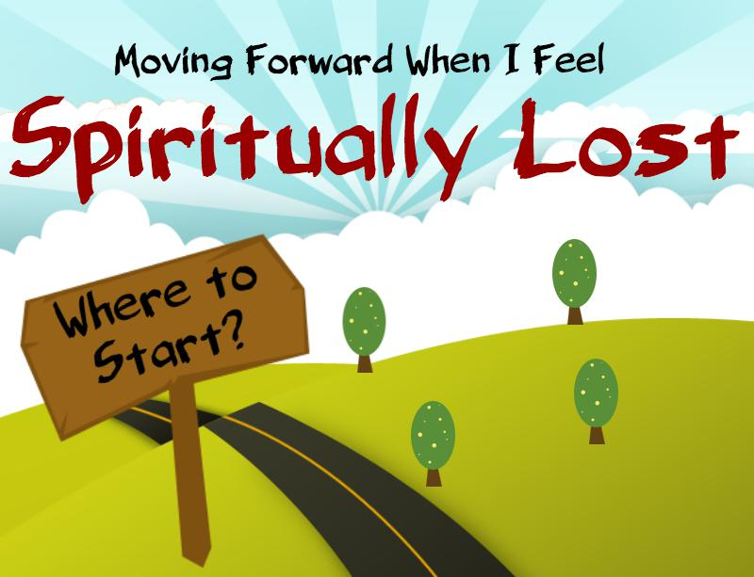

Gradually, unhealthy personal and social behaviors toward the world led to greed, breakdown of society, individualism, political division, violence, consuming ego and patriarchy. Consequently, people in the world are suffering. But suffering is an invitation to healing, usually through spiritual practices. Thomas Merton affirms, “Spiritual practice is not only about moving to the diamond center of our own being. It is about plunging deep into the heart of the world.” Moving deep into the heart of all things is an essential feature of authentic spiritual practices for all religions .George McLeod further explains, “Matter matters, because at the heart of the physical is the spiritual.” Spirituality is the foundation of our actions as we move forward into the future, Now that theologians and scientists are communicating with one another, a new and different relationship with the world is being born.

Pope Francis is endeavoring to bridge the gap between science and religion as stated in his encyclical, “If we are truly concerned to develop an ecology capable of remedying the damage we have done, no branch of the sciences and no form of wisdom can be left out.”

**HOW THE WORLD WORKS – COSMOLOGY**

Cosmology is the science that is necessary to understand the total picture of Earth’s evolutionary process to the very present moment. Cosmology is most important because it is crucial to understanding why human behavior continues to threaten our world today.

Cosmology explains how organisms relate to one another. There are three principles:

**IDENTITY** – tells what something is interiorly. e.g. oxygen **COMMUNION** – One identity interacts with another identity - hydrogen and oxygen. **DIFFERENTIATION –** while in communion, the two identities create something new. When the identities of hydrogen and oxygen act in **communion**, they form something new and different, a **differentiation** called water.

Everything in the universe came into existence through the cosmological principles. They are the basis for evolution and operated for billions of years. It began with the Big Bang and continues today. Identity is where the process originated, differentiation is how new configurations developed. When it comes to evolution, change is an absolute.

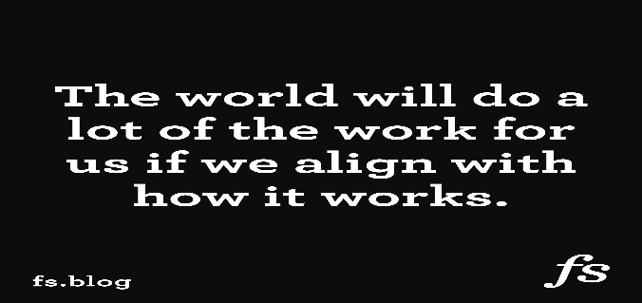The evolutionary process happens **automatically** in nature. However, the process does not happen automatically with humans because they possess **free will** and can make their own decisions on what to do. Free will decisions about Earth were made by humans without any consideration for the environment

**WHAT SCIENTISTS ARE ASKING IS THAT HUMANS USE THEIR FREEWILL TO**

**RELATE WITH EARTH AS EVNIRONMENTAL SPECIES DO NATURALLY.**

These principles provide the best guidance for humans to survive. Since human behavior is destroying Earth, changing human behavior may be able to end this crisis. Grim and Tucker further state, “Earth is crying out and humans need to listen.”

**WHAT ARE SCIENTISTS SAYING ABOUT THE WORLD?**

Brian Swimme describes the Universe as the primary revelation of God as the Universe is made in the image and likeness of God. He further states, “We are the first generation to learn the comprehensive scientific dimensions of the Universe.” Mary Evelyn Tucker and John Grim, in their delightful book, ***The Christian Future and the Fate of the Earth*** predict, ‘The only viable future for the planet or for ourselves is to recognize the separation that we have caused and enter a new era that we might think of as an Ecozoic era, a period when humans would be present to the planet in a mutually enhancing manner**.”**

Scientists and theologians are warning about the fate of the world and that life can no longer exist as it is now. Ilia Delio claims, “We humans have forgotten how to read the stars. We have become the most unnatural of species disconnected from nature and from one another.”

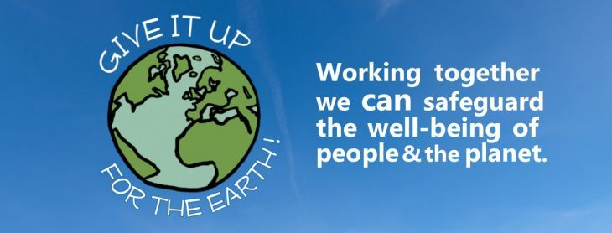

In today’s society, humans are very conscious of the beauty and radiance of world visions that are still in our bodies. Thomas Berry, in his book ***The Great Work***, shares how, as a youth, he saw a vast field of lilies that dramatically changed his life. Years later he reflected on that moment.

“Perhaps it was a sensitivity that was developed in my childhood. Yet as the years pass this moment returns to me, and whenever I think about my basic life attitude and the whole trend of my mind and the causes to which I have given my efforts, I seem to come back to this moment and the impact it has had on my feeling for what is real and worthwhile in life.”

Ilia Delio in her book*,* ***Making All Things New***, shares another story about lilies. “When Jesus asked the disciples to look at the lilies of the field, I think he was asking them to read the book of nature as the book of God. The lilies do not simply reflect God, rather **God** is being **God IN** the lilies – incarnation.”

To live in the lilies of the field is to be human in a global setting. Creation is still evolving waiting for human partnership. Aligning ourselves with cosmological principles is to be a co-creator with God. Teilhard de Chardin, in his book, ***The Phenomenon of Man***, states, ”We can be saved only by becoming one with the Universe.”

**THE TASK NOW IS TO LOVE THE WHOLE WORLD WITH ALL YOUR HEART.**

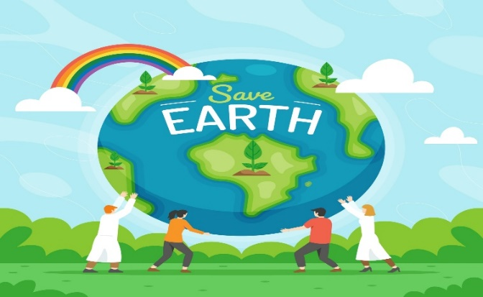

The first step in loving the world is to emotionally leave the status quo of life in order to find space for love to be reborn in you. Love is the foundation because love is our reason for being. we are invited to enter that journey with love for the world.

Love is also a critical part of the evolutionary process: identity, communion and differentiation. When our identity is love being in communion with the world, the world can change, differentiate. There is hope through loving.

**WHAT DOES IT MEAN TO LOVE THE WORLD?**

Most people in the world know what a loving relationship means. Just think of the power in the words, I love you. Where there is love, there is respect, generosity, support, willingness to change when necessary and do anything to make the relationship better. Love is to give your heart away. The world is crying for this kind of love because Earth and its people are one. Our SSJ charism stretches us to have a loving global relationship with God in the world.

Teilhard de Chardin spoke of a heart-to-heart relationship with God in his 1950 book, “***The Divine Milieu***. Teilhard’s prayer was, “Grant that my love may become an unlimited and endless contact **with a communion with you through the world**.” He invites us to “Hold our course toward confidence, not in the world but in the Heart of the world.”

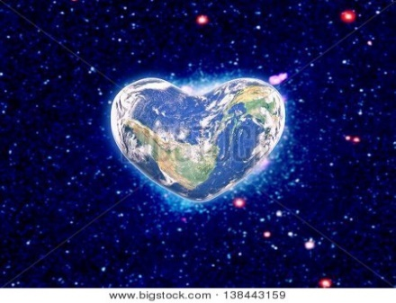

In John 10:10, the Spirit is revealing through our consciousness, a new sense of loving on a global level., “I have come that you may have life and have it **abundantly**.” John 3:16, “**God so love the world** that God sent his only begotten son**…** “ Can you imagine the love behind these words? Jesus came to teach us how to live and love life. There is no greater action of love than the presence of Jesus entering the world. Now is the time for us to return that love and become co-creators.

**A new door is opening above a new stage for development. If each of us can believe that we are working so that the universe may be raised in us and through us, to a higher level- then a new spring of energy will well forth in the heart of Earth’s workers.** Teilhard De Chardin

Teilhard’s message is one of love, a love that can never vanish. He believes that the world can be created in love’s image, A quote of his famous words that have been a part of our life for so long are, “We shall harness for God the energies of love and for the second time in the history of the world, humans will have discovered fire.”



**FINAL PRAYER**

**As we go our separate ways, let us draw a spark from the Great Fire. So that returning to our homes and cities, each of us will perpetuate the Great Fire… From which others will draws forth sparks to sustain that flame… Thus, in turn, sparking their Fire… Which sparks other Fires… Until all the land is filled with light and warmth, And this is how Light and Love return to our planet, Earth. From heart to Earth.**

Author Unknown

Lorraine Villemaire for the SEED Committee.