| **LSAP Reflection** |
| --- |

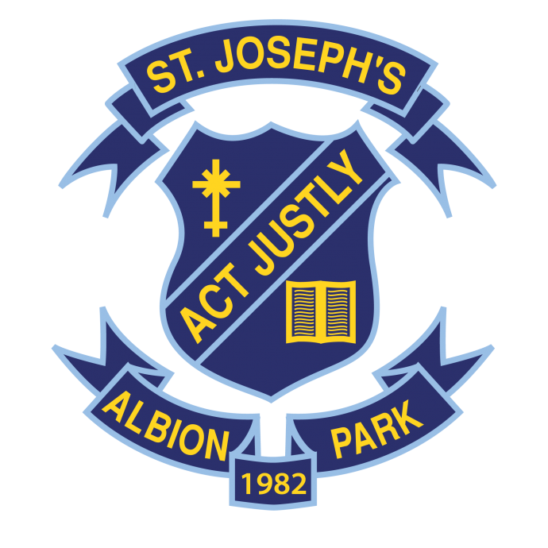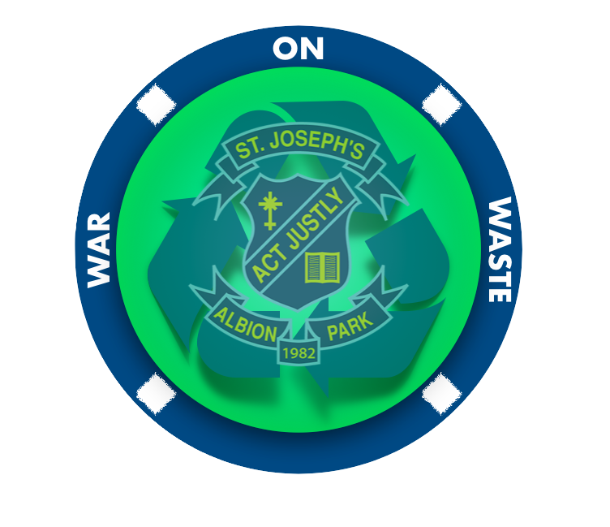

**St Joseph’s Catholic**

**High School**

**Albion Park**

| **About St Joseph’s Catholic High School** |
| --- |

St Joseph’s High School is a systemic co-educational Catholic High School catering for students from Year 7 to Year 12. The school provides a quality Catholic education for young men and women in the southern Illawarra, drawing students from areas bounded by Gerringong and Kiama in the south, Unanderra in the north, Shellharbour and Warilla in the east and Albion Park in the west.

The school has a proud tradition as a caring and vital Catholic community where each student has the opportunity to realise goals and focus on their learning. St Joseph’s has an expanding sustainability and environmental program. The Grounds program features student involvement in maintaining gardens, tending bush tucker and vegetable gardens and engagement with waste management systems.

As a faith community, there is an emphasis on the total development of students. The spiritual, social, academic and physical dimensions are underpinned by parish input, a rich liturgical tradition, our SOLE Goals (Self, Others, Learning, Environment), community events such as St Joseph’s Day, social justice inspired whole school events and an extracurricular program which encourages full student engagement.

The motto of the school is “Act Justly”. Justice is a value we all seek, not only in society today, but in our own lives and our own hearts. Mission is the underlying or fundamental theme of the gospel. We share in Christ’s mission to bring good news to the poor, sight to the blind, and freedom to captives. Through this sharing in the mission of Christ we are empowered to act justly. This liberates us to free the world from all that hinders, oppresses or destroys.

The motto of “Act Justly” invites each of us to take seriously the call of ecological conversion to act with justice for God’s creation. We need to take seriously the challenge from Laudato Si’ to care for our common home. At St Joseph’s we see that it is crucial that we take action to be sustainable stewards and responsible citizens that contribute to the building of a better future for humanity and our planet. We are encouraged to do justice, as God does justice, and when God does justice, it is not modest or polite or understated. It is an act of powerful intervention and we are called to intervene on behalf of all of creation.

This School Environmental Management Plan (SEMP) is a tool that will enable us to document, implement, reflect and celebrate sustainability as we respond to the challenges from Laudato Si’ to walk our own journey of ecological conversion. At St Joseph’s we understand that we have a missionary and ecclesial mandate that impels us to participate and respond to the call to care for our common home with strategic planning, formation and concrete actions and it is within this context that this SEMP is formulated.

| **About St Joseph’s Catholic High School** |
| --- |

St Joseph’s Catholic High School is situated in Macquarie St Albion Park. The Illawarra Highway runs through Albion Park and joins the Princes Highway north of our suburb. We also have the Illawarra escarpment to the west, Dapto to the north, Jamberoo to the south and Shellharbour to the east.

We claim to be a Catholic High school out in the country with its farmlands and new housing estates surrounding us, harbouring its rich history and traditions of the community of Albion Park. We at St Joseph’s value the space in this semi rural community and immerse ourselves into the community.

Our school draws from a wide range of socio economic groups from varied cultural backgrounds.

The grounds have a substantial number of trees throughout and extensive gardens. A large grassed oval, two sealed basketball courts, a gymnasium, and a grassed netball court area serve as sport and outdoor areas for the students. A number of vegetable gardens are located behind the Science block, and further vegetable gardens are found near room F10. A citrus garden continues to flourish behind the canteen.

Over the last few years there have been additions and improvements to the grounds of the school: Aboriginal Welcome poles and garden space at the entrance to the school, succulent garden planted, the memorial garden was reinvigorated, the TAS building was gutted and renovated. There have been some classroom improvements such as new furniture and painting of walls.

Students in years 7-9 are encouraged to bring laptops to school, and students in years 10-12 bring laptops to school. Teachers are all provided with MacBook laptops. The physical environment has natural and human made structures to provide shade.

| **Belonging to the Catholic Education Diocese Wollongong** |
| --- |

Since 2015 following the release of Laudato Si’, Catholic Education Diocese of Wollongong has taken seriously Pope Francis’ prophetic call for an ecological conversion and has proactively responded in a strategic, planned approach whereby sustainable practices and ecological values are promoted and supported across the system of schools in the Wollongong diocese.

Engagement with eco-spirituality, environmental education and action is a key component of our mission, of being Catholic and is viewed as “core business”, not an “optional or a secondary aspect of our Christian experience” (LS n217)

This strategic approach has involved schools embedding ecological values into school programs and practices that promote an ecological and sustainable culture, encouraging everyone to live out his/her ecological vocation and engage in caring for our common home.

St Joseph’s Catholic High School has implemented and engaged in an Environmental Education Action Policy. The Wollongong Environment Network (WEN) Contact is Natalie Behl, who works with the Religious Education Coordinator (REC), as well as staff and students to plan and implement this policy by using a **School Environment Management Plan** (SEMP). In my role as the WEN contact I have worked with Beth Riolo form the Catholic Education Office to create a SEMP for a three year period. We are on our second SEMP and were successful in many of our School’s goals in the SEMP 1 Process during 2018 to 2020.

The overall mission of CEDoW is articulated in *Lighting the Way* *Vision and Strategic Direction 2019-2022*. This SEMP connects directly with: Mission Dimension 1, **Mission and Catholicity**

* **Vision** 1.7 *Ecological conversion and sustainability are witnessed in the day-to-day life of the educating community*
* **Realising the Vision** - *Implement the Diocesan Environmental Education and Action Policy to demonstrate fidelity to Laudato Si’*

St Joseph’s is involved in the Catholic Education Office ‘School Review and Improvement’ process, as are all schools in the Wollongong diocese. Through this we review all aspects of school life, seeking to make improvements in all areas to the betterment of our students. This ongoing improvement continues, especially in the area of sustainability.

This plan connects to whole school planning through the following:

• The school’s SRI plan

• Part of the school annual plan

• Reported on in the school annual report

• Integrated with curriculum programs

• Links to regional education and local government planning

• Links to extra-curricular activities for students

The following is an overview of significant environmental actions and initiatives undertaken during the first SEMP cycle.

* Encouraging staff ownership and responsibility in promoting and supporting the school’s ecological conversion journey. This is ongoing and needs to be reinvigorated after COVID where many of our waste management practices were on hold to manage the spread of COVID.
* Incorporate ecological themes in liturgy and prayer and acknowledge some key environmental days. The REC and Assistant REC are always preparing liturgy and pray for significant environmental days. During the past two years of COVID, we have not had many opportunities to meet in person for liturgies. This is something we are looking forward to starting again in 2022.
* Extending the school-wide waste management system incorporating a streamed bin system into each playground area (FOGO, yellow recycling, landfill, Return and Earn, REDcycle soft plastics) was major achievement for our school, leading other schools in the diocese on how to implement this. Unfortunately Joey’s Waste Management System needs to be reinvigorated post COVID. This is a major goal for our school in 2022.
* We had developed a whole school procedure outlining roles and responsibilities for the waste management system, FOGO, garden maintenance and management. This procedure will need to be altered post COVID with a more strict plan to minimise contamination of germs/virus.
* Waste-free food days and paper-free days for staff and students are some of the Environment Days we have been able to implement and look forward to continuing these this year.
* Staff recycling pod that includes: TERRAcycling that include; (stationary, toothbrushes/toothpaste /dental floss and single use masks), bread tags, batteries and blister packs.
* CEDoW EEA Education Grants were utilised for the streamlining of Waste Management - four coloured bins (GREEN - organic, RED - landfill, YELLOW - mixed recycling and BLUE - paper recycling) throughout the school. This was put on hold for the last two years. We were able to implement the blue Vinnies Bin for containers in Term 4 - 2021 but plan to reinvigorate the Five Bin Pod Waste Management System.
* Have established community networks - Bunnings Kembla Grange, Shellharbour Council, Uncle Kev, Green Caffeen, Reduce, Reuse, Recycle - Kiama and Wollongong Botanic Gardens.
* Environment Club called the War on Waste (WOW) Club formed in 2017 with the initial aim of introducing recycling to the school. A group of students and teachers conduct waste audits, help sort through and empty bins, create educational posters and videos, and work on a number of other environmental initiatives. This is always ongoing, however once again with not being able to mix cohorts and much of our time in Lockdown in 2021, I am very much looking forward to making this happen again in 2022.

Each year, the WEN contact from each school around the diocese meet so we have a chance to network, share ideas and environmental actions as well as initiatives. This is part of my Professional Development throughout the year as well as other ‘connection’ days with local schools. Our school also participates in Spirituality Days and Environment Days, such as Clean Up Australia Day and World Environment Day. I also pass this information onto staff and students through speaking on Assembly and Staff Meetings and of course by leading by example. In many cases, staff and students have taken up practices in their homes that they otherwise would not have done.

Joey’s has been lucky enough to receive CEDoW Environmental Education Grant with another one granted just a month ago for 2022. CEDoW EEA Education Grants were utilised for the streamlining of Waste Management - four coloured bins (GREEN - organic, RED - landfill, YELLOW - mixed recycling and BLUE - paper recycling) throughout the school. This year's grant will be used for a Community Outdoor Classroom. The development of an outdoor learning space, with a sustainability theme allowing for teaching and learning across KLA’s.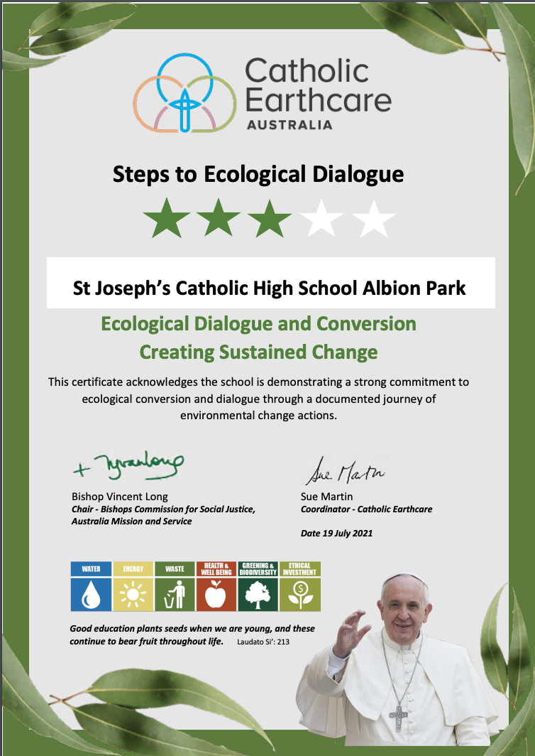

Joey’s is a Level 3 Accredited Earthcare School

The Australian Catholic Bishops’ Social Justice Statement 2021-22: [*Cry of the Earth, Cry of the Poor*](https://socialjustice.catholic.org.au/wp-content/uploads/2021/08/Social-Justice-Statement-2021-22.pdf), affirms that “we human beings need a change of heart, mind, and behaviour”. It exhorts us all to care for creation and the most vulnerable people in our worldwide human family. Joey’s participates in many activities to affirm our connection to the Social Justice Statement 2021-22: [*Cry of the Earth, Cry of the Poo*](https://socialjustice.catholic.org.au/wp-content/uploads/2021/08/Social-Justice-Statement-2021-22.pdf)*r.* Our school has a Youth Ministry Club and a War on Waste Club that are often the drivers of days like Clean Up Australia Day, Vinnies Appeal, Project Compassion, Soup/Can drive, Vinnies Return and Earn Bins, Earth Hour, and World Day of Prayer for Creation. Between myself as the WEN Contact, the REC and classroom teachers, we participate in many activities around the school such as liturgies, use recycled paper in the print room, Market Day for Commerce, sustainability across KLA’s and simple things like changing single use sugar to a jar of sugar.

| **Laudato Si’ Action Platform** |
| --- |

The Laudato Si’ Action Platform empowers the universal Church and all people of good will to respond to [Laudato Si’](https://www.vatican.va/content/francesco/en/encyclicals/documents/papa-francesco_20150524_enciclica-laudato-si.html), Pope Francis’ encyclical on caring for our common home. Joey’s has this in the forefront of a school whose mission is “The motto of the school is “Act Justly”. Justice is a value we all seek, not only in society today, but in our own lives and our own hearts. Mission is the underlying or fundamental theme of the Gospel. We share in Christ’s mission to bring good news to the poor, sight to the blind, and freedom to captives. Through this sharing in the mission of Christ we are empowered to Act Justly. This liberates us to free the world from all that hinders, oppresses or destroys in the way of light joy, compassion and love.”

1. Response to the **Cry of the Earth:** using water tanks to water the garden, solar power that powers our air conditioning, reducing fossil fuels in order to achieve carbon neutrality, efforts to protect and promote biodiversity, guaranteeing access to clean water for all, etc.

2. Response to the **Cry of the Poor:** fundraising for charities, defence of human life from conception to death and all forms of life on Earth through several of our KLA’s, with special attention to vulnerable groups such as indigenous communities, Vinnies Appeal at Christmas time and soup/can appeal during winter for example.

3. Ecological **Economics:** ethical consumption on things we purchase to run the school such as recycled paper, certified companies that use ethical practices, divestment from fossil fuels and any economic activity harmful to the planet and the people such as solar panels.

4. Adoption of **Simple Lifestyles**: minimising the use of resources and energy throughout the school, avoiding single-use plastic in the staff room and the canteen as well as for functions, using online learning platforms instead of paper, bringing drink bottles to school and nude food.

5. Ecological **Education:** over the past few years the curriculum has had to be re-thought and redesigned to reform the spirit of integral ecology to create ecological awareness and action, promoting the ecological vocation of young people, teachers and leaders of education. This not only happens in the classroom but also on assemblies and through initiatives and celebrating days like World Environment Day.

6. Ecological **Spirituality:** Joey’s ecological spirituality journey is present in our school through Catholic Studies, especially in the Year 7 Stewardship unit to recover a religious vision of God’s creation, encourage greater contact with the natural world in a spirit of wonder by getting outside on the the school grounds to learn and ‘wonder’, liturgical celebrations throughout the year such as the World Day of Creation for Creation, develop ecological catechesis in the War on Waste Club and throughout Catholic Studies, daily prayer, and annual retreats for Year 12, and annual Staff Spirituality Day.

7. Emphasis on **Community involvement and participatory** action to care for creation at the local, regional, national and international levels, promoting advocacy and people’s campaigns through subjects like PDHPE and awareness prayers like International Womens’ Day, encourage rootedness in local territory especially with the indigenous community.

| **ASSISI Framework** |
| --- |

ASSISI provides a model and strategic pathway towards greater ecological sustainability. The underpinning framework of ASSISI is relevant and appropriate for all Catholic organisations and agencies, parishes and religious congregations, such as St Joseph’s Catholic High School. ASSISI provides organisations with direction and a coherent response to the call for ecological conversion.

When each school creates their SEMP in consultation with Beth Riolo from CeDoW we look at how the

**ASSISI Framework** fits into our three year plan. Over the past three years, Joey’s has been able to achieve and will continue to achieve, some of the ASSISI Framework Goals. We have developed some strong values to care for our school, our community and our world. We have been able to do this through prayer, celebrations of special world environment days and the schools and individual’s environmental achievements, education in Science, HSIE, RE and English, assemblies and more. This has all paved the way for our students and staff to see creation as a gift and have a relationship with our environment and a real sense of responsibility for its future.

The CeDoW and the WEN contacts have been instrumental in helping our school develop awareness, knowledge and skills to help our student’s ecological journey with the aim of them taking home what they have learnt to practice it in the household and maybe even educate other family members so that we improve our local, regional and global environments;

Joey’s started this ecological journey 4 years ago, where a War on Waste (WoW) Club was formed and some passionate teachers got together to develop an ongoing reflection learning processes that include articulating, monitoring, evaluation and sustainability indicators. Unfortunately the WoW Club has struggled over the past two years of COVID with not being able to meet regularly and having minimal time at school to implement ideas and projects. We are starting a new framework in the very near future to reinvigorate this club and staff input.

During the first SEMP an audit of our waste was conducted. This was done by the then coordinator’s Science Class and by the time we wanted to do this again COVID was among us. This along with an Audit of our ecological footprint including carbon, energy and water will be part of our plan for 2022.

We have been able to forge many relationships with people and groups outside of Joey’s. These relationships have given us a platform to develop the needs of our environment by way of sharing ideas, successes and more people power working together.

| **Posters/Images created for initiatives at St Joseph’s Catholic High School** |
| --- |



