We the Holy School community of Guwahati have done as per the 7 goals of the Lodato Sii which is going with the Integral Ecology.

1. **Response to the cry of the earth**
2. As a community we have made effort to save energy by switching off the lights when not needed and unplugging electronic devices when not in use.
3. We use water sparingly and responsibly
4. 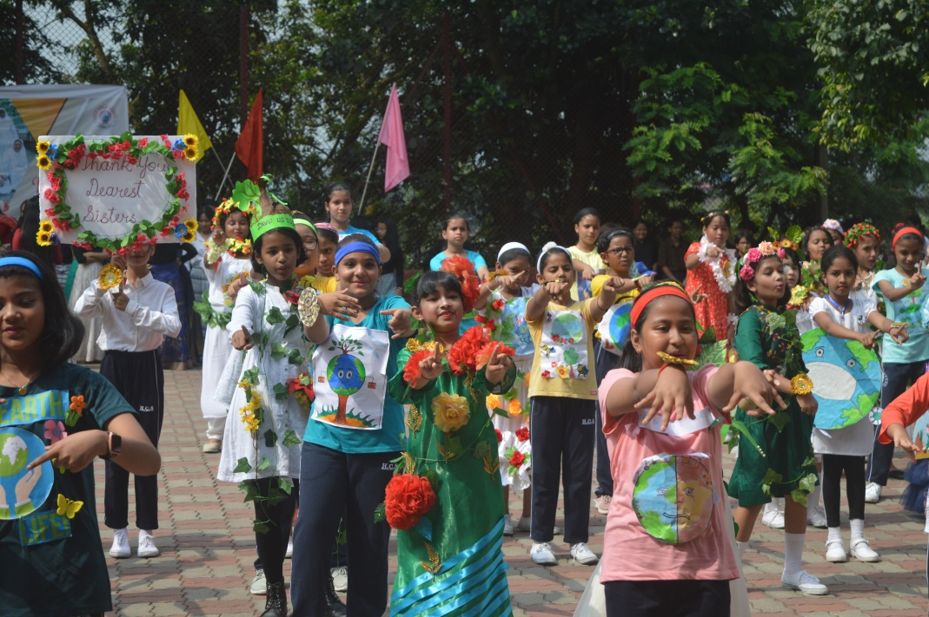 During the golden jubilee celebration of the school we choose to use only paper packets for snacks.
5. We teach students during SUPW class to prepare and use paper shopper bags and pencil and pen holders.

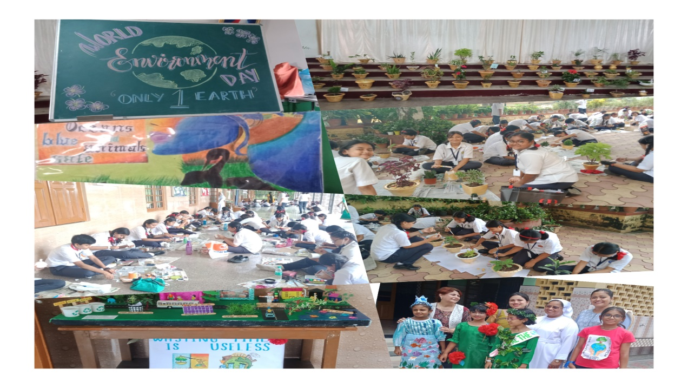

1. **Response to the cry of the poor**
2. Adopted a poor child by giving books and a bicycle to go to school.

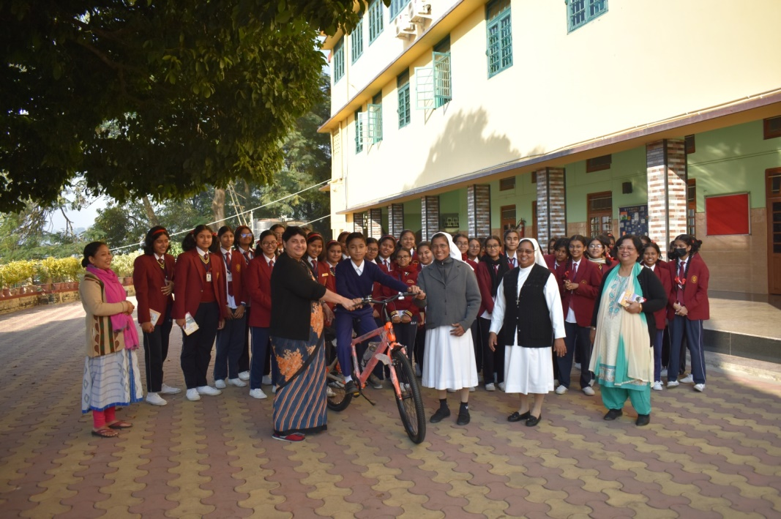

1. Fees reduction is given for about 53 students and supports 12 students with free books.
2. Motivated teachers to give free remedial classes to the academically poor students.

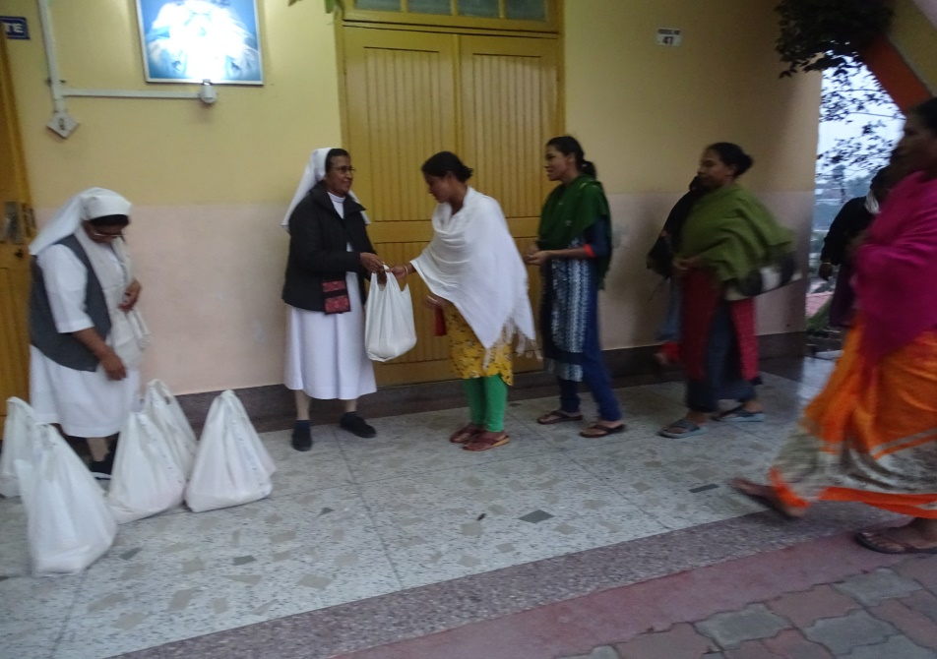

1. Shared essential commodities with the poor during the Christmas celebration.

(2 photo)

1. **Ecological Economics**

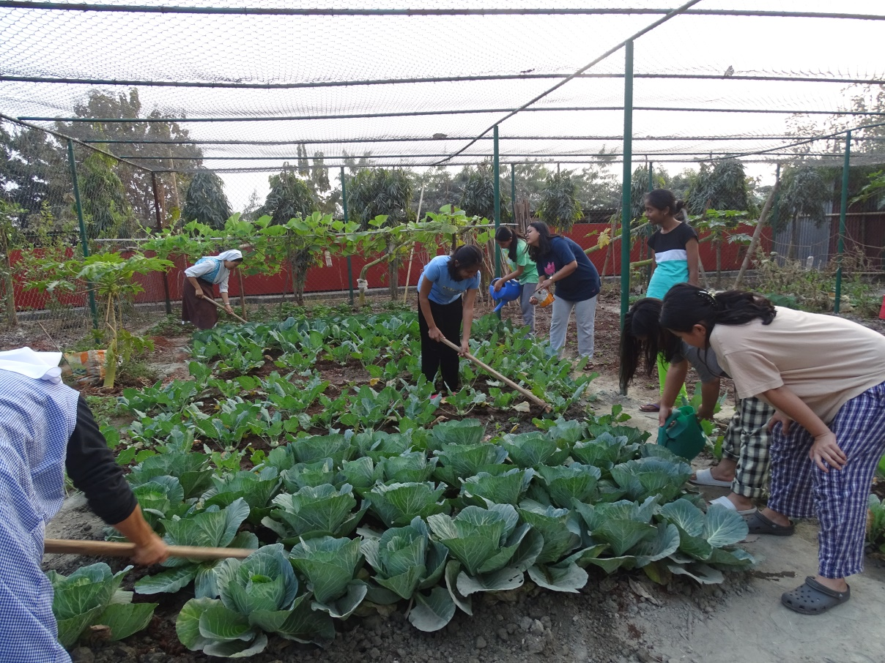

1. Created and cultivated new kitchen gardens.(3 photo)

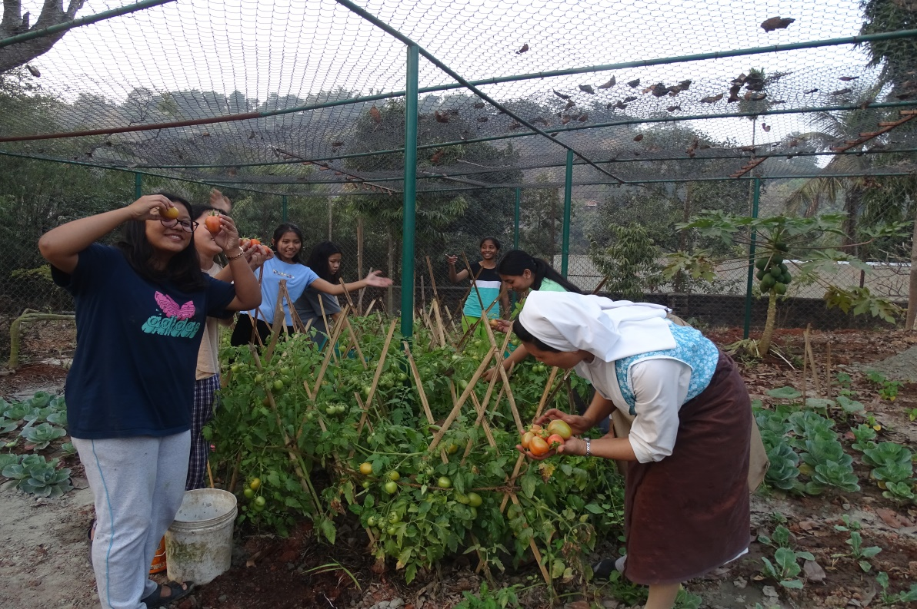

1. **Sustainable Ecological Education**

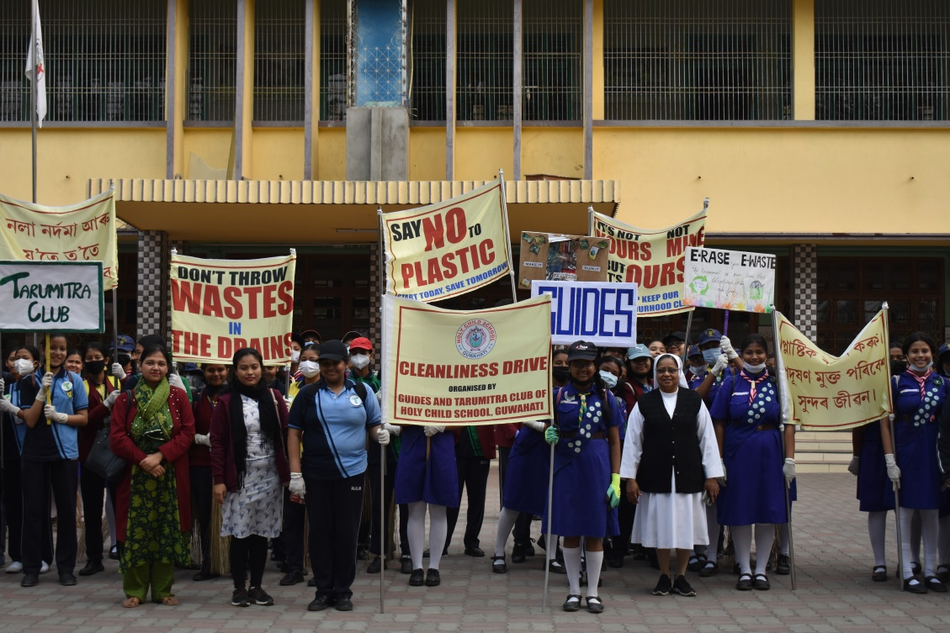

1. Organized awareness rallies on ecology (4 photo)

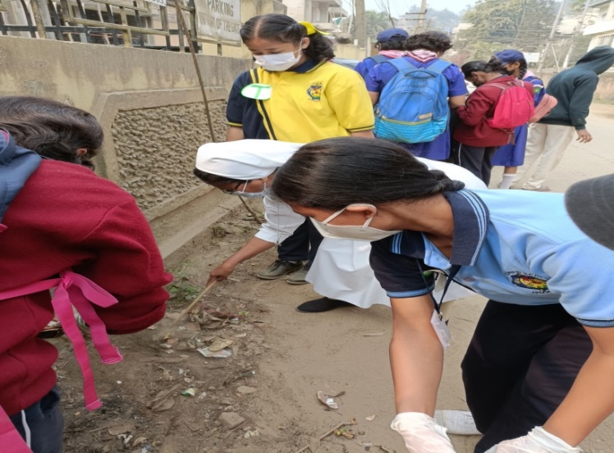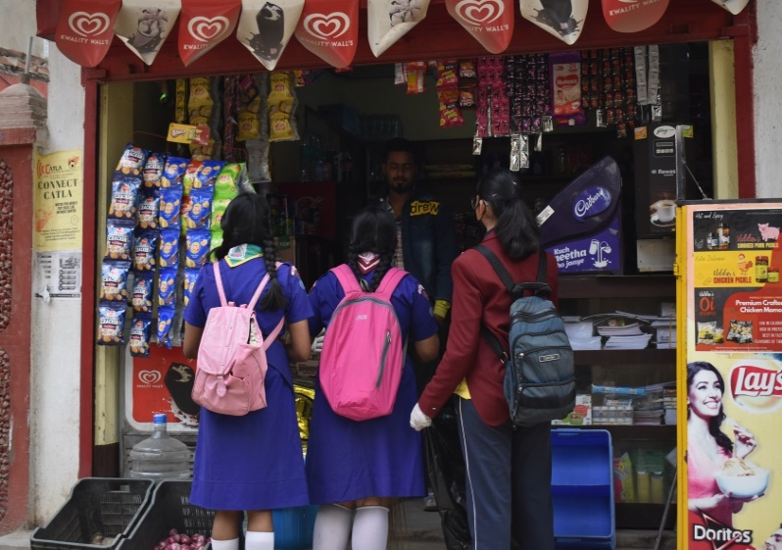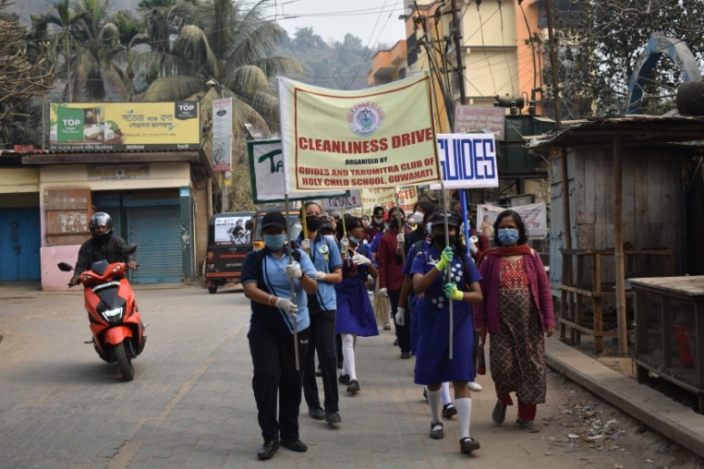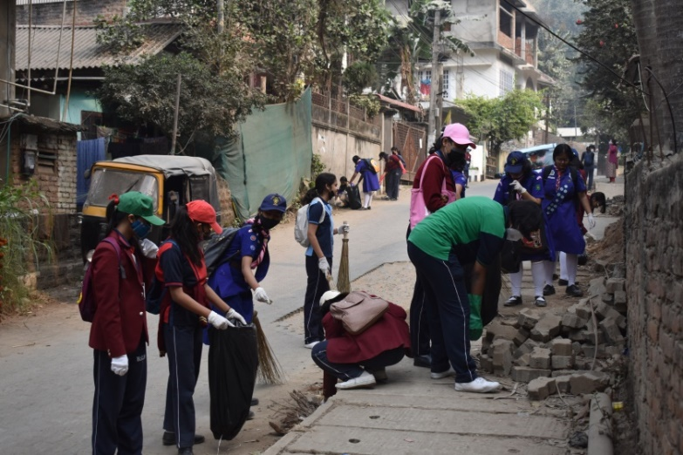

1. 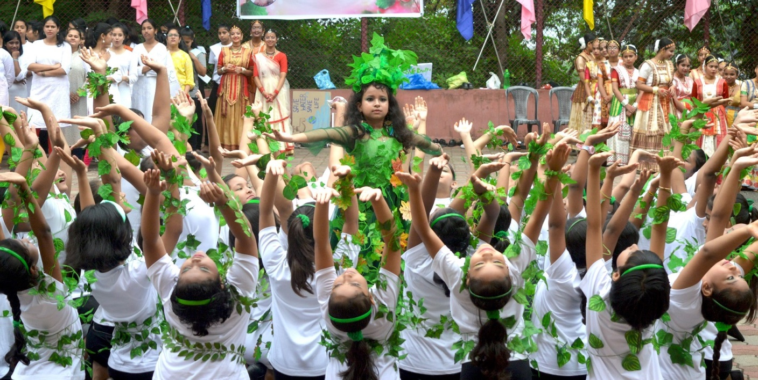During the different celebrations, through programmes brought awareness among students, teachers and parents (photo)

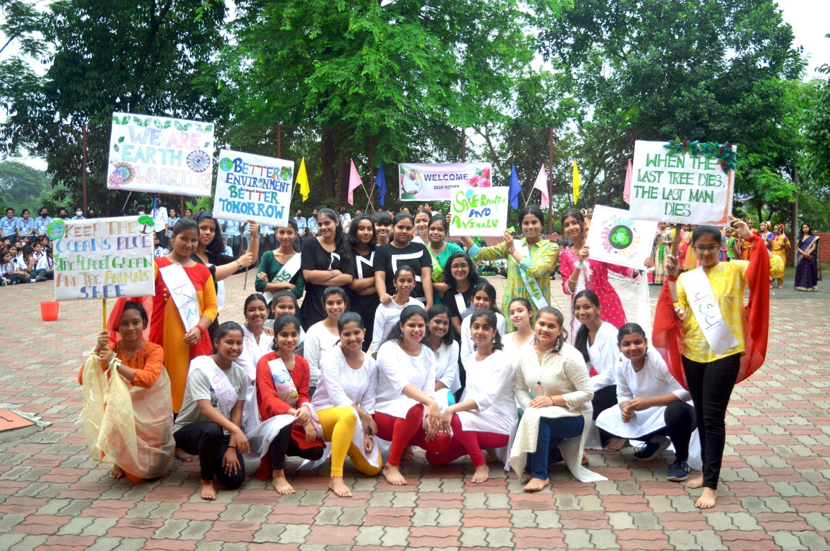

1. Eco Club “ Tarumitra” of our school Conducted painting competition based on ecology (5.photo)

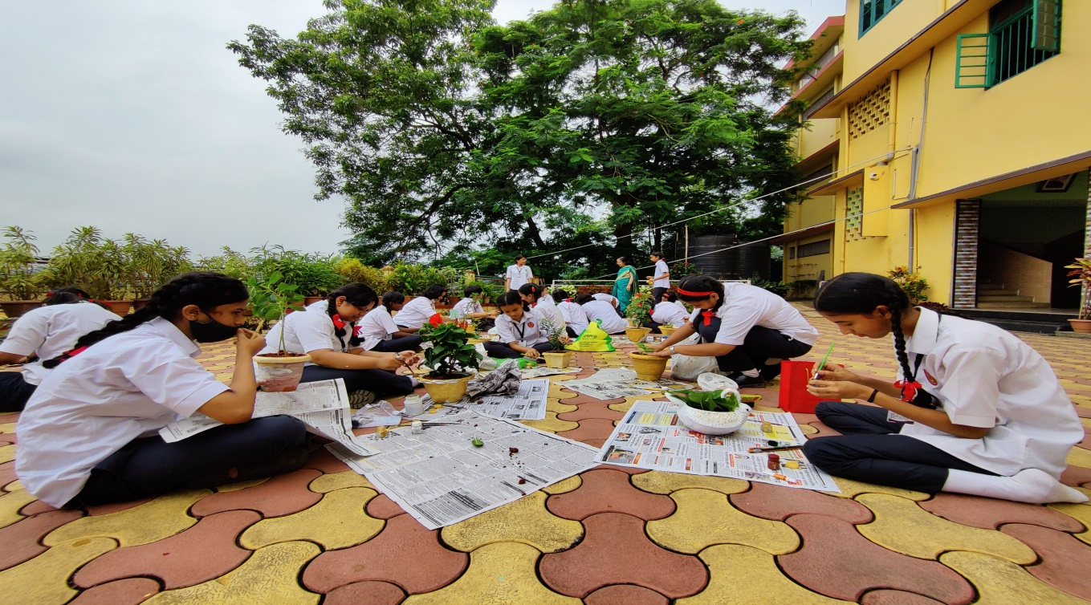

1. **Adoption of sustainable lifestyle**

Organized nature outings and picnics for boarders on the river side and mountains.

(6. photo)

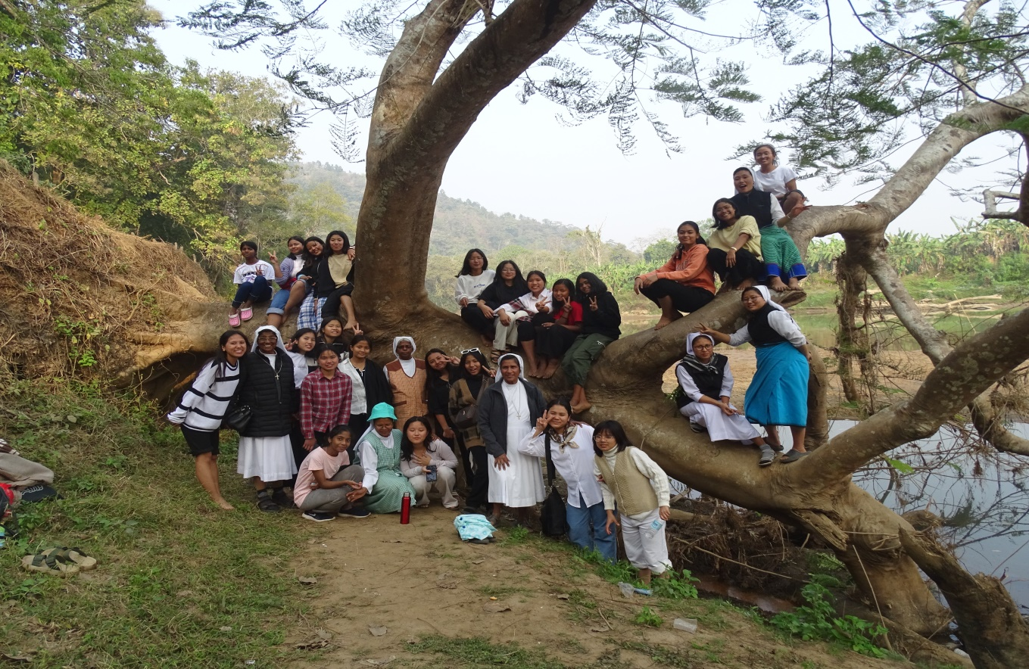

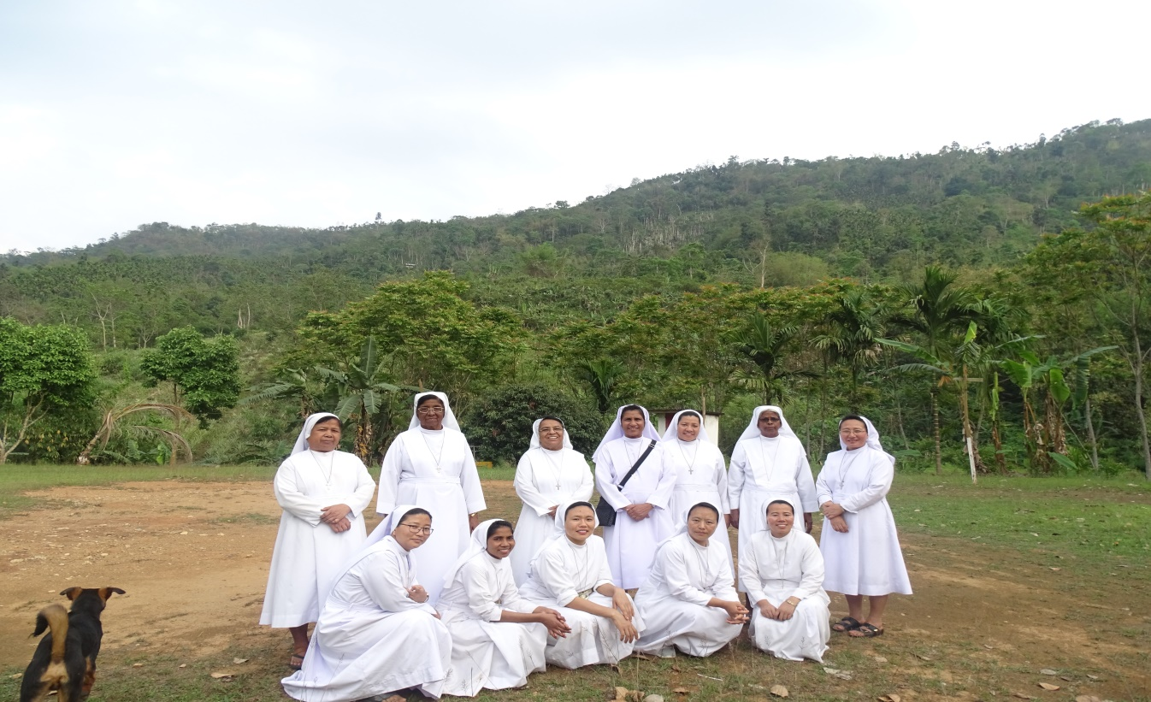

1. **Ecological Spirituality**
2. Organised nature meditation for students during the moral science class.
3. Celebrated season of creation with parishioners during the Sunday Eucharist

(7 photo)

1. The community did a deeper study on the document “ Lodato sii” for better practical understanding of integral ecology.
2. Celebrated the environment day and eco days with creative programmes and prayer services.