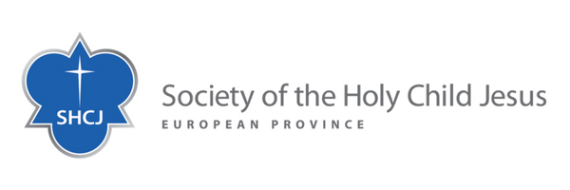

**REFLECTION OFFERED BY THE EUROPEAN PROVINCE OF THE SOCIETY OF THE HOLY CHILD JESUS**

**The Society of the Holy Child Jesus, an international congregation of women religious in the Catholic Church,** was founded in Europe – in Derby, England – in October 1846 by Cornelia Connelly, who was an American. The Society now spans four continents in three provinces: African, American and European, where we work collaboratively with others in educational, spiritual, pastoral, social and healthcare ministries.

As Sisters of the Holy Child Jesus, whose charism is Incarnational, we recognize the need to connect our passionate love for humanity with an equally passionate concern for the protection of our world. ([Laudato Si](https://laudatosi.com/watch). 216). An understanding of Incarnation today embraces the whole of Creation and the flourishing of the whole web of life.

Our concern and our endeavours to respond to the cry of the earth and the cry of the poor have been shared amongst us for many years, as we became more and more aware of what is happening to our common home and the human family we are called to serve. We have repeatedly stated this in our general chapter commitments and shown it in our life and ministry. When **Laudato Si** was published it gave even more impetus to our efforts. In that encyclical Pope Francis appeals to us in these words:

*“The urgent challenge to protect our common home includes a concern to bring the whole human family together to seek a sustainable and integral development, for we know that things can change.” LS 13*

At this time the European Province of the Society of the Holy Child Jesus has entered into a process of completion. There are 56 sisters in the province, the majority of whom are aged over 80 and 26 are living in the province care home. But whilst we have, for example, ensured that the schools we founded have been handed over and are flourishing, our charism continues to impel us to “Actions not Words”, our Society motto. So, when we learnt about the establishment of the **LAUDATO SI ACTION PLATFORM,** its call to ecological conversion, its organisation and Goals, we recognised that here was a truly powerful way of working, in solidarity with others, to create and sustain that critical mass needed to transform our world. As we formulate our province plan for the coming years, with the Laudato Si Goals to guide our actions, assisted by the resources made available to us and working in collaboration with others, we know that we shall be better able to respond to Pope Francis’ urgent call.