In the wake of his recent death, there have quickly been released a wide array of articles and interviews about the life and legacy of Pope Benedict XVI. The commentaries made in these pieces touch on everything from the early life of Joseph Ratzinger to his participation as a theological consultant at the Second Vatican Council to his years as the Prefect of the Congregation for the Doctrine of the Faith to his papacy to his resignation in 2013 and his life thereafter as Pope Emeritus.

From the perspective of the Laudato Si’ Action Platform, a key element of Benedict’s legacy is in his writings on the environment and on creation. While Pope Francis is widely associated with the care of creation and ecological concerns, Benedict XVI wrote and spoke about so much in this area that he became widely known as the “Green Pope”. This was not only reflected in his writings but also in actions, as it was during Benedict’s papacy that the first solar panels were installed within the confines of the Vatican City State.[1]

This should not entirely come as a surprise, not only because of the fact that ecological matters were increasingly becoming a part of the general public discussion, but also due to his own research in Franciscan theology as a young theologian, having published *Theology in History in St. Bonaventure* for his *habilitation*, which then gave him the necessary qualifications for a professorship in the German academic system.

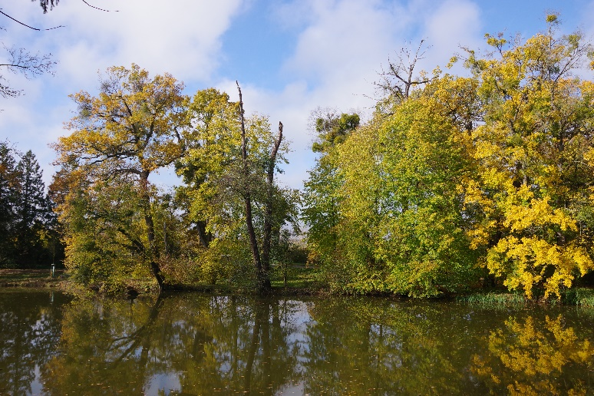Over the next few weeks, we will be releasing a series of seven brief articles which examine the writings of Benedict XVI as they relate to the Laudato Si’ Goals, as described in the Laudato Si’ Action Platform. In no way is this intended to be an exhaustive analysis of Benedict’s writings and teachings with respect to the topic of ecological conversion. Rather, we offer it this as a point of reflection, taking note of the late pope’s contributions with respect to the Church’s teachings in this area as we move forward in our commitment in this area.[2]

Photograph by [Jan Helebrant](https://www.flickr.com/photos/96541566@N06/), licensed under the [Creative Commons Attribution-Share Alike 2.0 Generic](https://creativecommons.org/licenses/by-sa/2.0/deed.en) license.2

1. Pullella, Philip. 2008. “Vatican Set to Go Green with Huge Solar Panel Roof.” *Reuters*, November 25, 2008. <https://www.reuters.com/article/us-vatican-environment-idUSTRE4AO8C820081125>.
2. Helebrant, Jan. 2019. “2019-11-07_11-02-01_Pentax_JH.” Flickr. November 7, 2019. <https://www.flickr.com/photos/96541566@N06/49443960252/>.