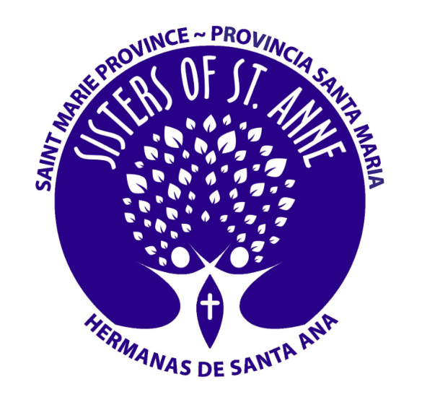Reflection on joining the LSAP

Laudato Si’ has always been in the forefront of how the Sisters of Saint Anne in the St. Marie Province live. This year of deeper exploration of the encyclical, filling out a probing survey and praying on the goals of the platform has led to a more profound understanding of what more we can do to protect our environment.
We have not only signed our commitment but have asked the four other congregations who live in community with us to join our journey. We are committed to continue to uncover the many layers of each goal, to reflect on how we are impacted by the challenge of each, and finally to find ways that we can make changes. We are an aging community, but we understand that this does not dismiss us from the work of caring for the gift of our creation.
The community is energized by this endeavor and ask the Holy Spirit to continue to open our eyes and hearts to how we are to proceed on this journey of the Laudato Si’ Action Platform.

