Season of Creation Prayer

(A short prayer to thank God for All of Creation and to plead for support in our continuous efforts.)

**Hymn:** **For the Beauty of the Earth** – John Rutter (YouTube)

Creator God, we give thanks for the wonderful gift of creation and your presence in every part of it.

As we seek to widen our circle of love, help us to rediscover the value, unity, and sacredness of all that exists.

We seek forgiveness for the ways in which our actions and choices have damaged the earth, affecting the climate, destroying diversity, and impacting the lives of the poorest of our sisters and brothers.

In your love, lead us into solidarity and companionship, inspire our leaders to courageous decisions, and grant each of us the wisdom and commitment to act.

May we treasure the earth’s resources, work to reduce our impact on the climate and be open to a conversion of heart and lifestyle. Amen

***What would the world be once bereft of wet and of wilderness? Let them be left.***

***O let them be left, wildness and wet***

***Long live the weeds and the wilderness yet.*** *Gerard Manley Hopkins*

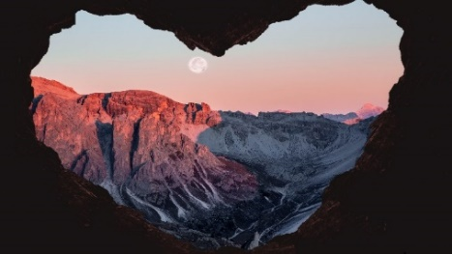For Reflection and Sharing on this question -

**What am I doing, now, to help the Climate**

**and Biodiversity**?

We pray that we may see you, Lord more clearly in the wilderness as well as the well-ordered streets, to change our lifestyles so that we may love those who are living at a subsistence level and to follow you with hope as we acknowledge that you are the Creator of our Future. This prayer we make in Jesus’ name. Amen

(Contributed by the FCJ Sisters)