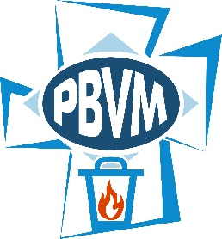

**Sisters of the Presentation of the Blessed Virgin Mary**

**New Windsor, New York**

[administration@sistersofthepresentation.org](mailto:administration@sistersofthepresentation.org) www.sistersofthepresentation.org

Laudato Si Action Platform

Reflection

Challenged by our charism to hear and respond to the cry of those made poor and deeply committed to our mission to care for Earth, we, the Presentation Sisters of New Windsor, New York along with our Associates and Presentation companions join the world-wide Catholic Community and commit to an ongoing journey toward sustainable lifestyles and integral ecology.

In light of our Chapter decisions made in July of 2021, we deepen our desire  to advocate for women and children as they are impacted by environmental, economic and racial injustices. We will continue to work for human dignity, justice and freedom.

Together we resolve to see “the world as a joyful mystery to be contemplated with gladness and praise”. (LS-12)

MISSION STATEMENT: We, the Sisters of the Presentation of the Blessed Virgin Mary, inspired by our foundress, Nano Nagle, commit ourselves to the Gospel values of hope, justice, freedom and human dignity. In union with one another, we pledge ourselves to act for and with the poor and oppressed of our world, and to care for the Earth.