**Laudato Si’ Action Platform Reflection Peter Dowling cfc**

This is an individual reflection, coming from my returning home to Australia after time in Rome as a member of the Congregation Leadership Team of the Christian Brothers. At our most recent Congregation Chapter, concluding February 2022, the following Statement was proclaimed, committing the Congregation to the Laudato Si’ Action Platform with the necessary actions that flow from that commitment.

The Cry of Mother Earth: Care for Our Common Home

As far as we know, the only planet in an immense universe on which life has emerged is our wonderful, blue planet Earth. Earth is home to myriad creatures, ourselves included.

Today, Earth is severely diminished by human ignorance and greed. We Brothers join with Earth as She cries out in protest.

In his encyclical Laudato Si’, Pope Francis calls each one of us to a transformation of heart and soul with a growing awareness of the ecological challenges facing our home, Mother Earth.

The Congregation Chapter calls each of our Brothers to embrace the Pope’s call to love and protect our planet through contemplation, prayer, and action,

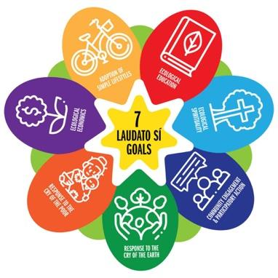

The Chapter commits the Congregation to support the

Laudato Si’ Action Platform, as invited by Pope Francis.

Province leadership Teams are asked to engage with their communities in these four main directions:

* Animating and accompanying local communities in their efforts towards an integral ecology.
* Promoting opportunities for the personal formation of Brothers in this area.
* Providing support and financial resources to engage in, for example, alternative energy plans and new investment strategies.
* Developing policies and guidelines essential to sustainable ecology.

Urgent Call to the Brothers

The Chapter calls us all into a deeper love for Mother Earth, leading to a fundamental conversion of heart, expressed in our daily life choices.



Of particular significance is the wording at the end of the Statement – the Urgent Call to the Brothers. *The Chapter calls us all into a deeper love for Mother Earth, leading to a fundamental conversion of heart, expressed in our daily life choices*.

I believe that this is the perspective which guides me. I am a member of the Congregation, a Province, and a local community. My sphere of involvement is now more at the local level – my community, my Province, and in collaboration with other people and groups in the area in which I live. There are opportunities for wider connection through Zoom meetings, and I gain the benefit of those when possible.

It seems to me that my own personal commitment is of first importance to me. If I am not clear in my own commitment, then I will not influence others in a positive way towards our collective commitment. Such things as regular reading of parts of *Laudato Si’*, highlighting significant days such as World Environment Day, bringing the key element of LS into our community conversation and prayer, inviting consideration of shared action that we might take all seem to be important at local community level. Such areas as simpler living, food preparation, waste and recycling are immediate concerns. Supporting any initiatives of the Province, especially the work of the Province Earth Sustainability Coordinator, and linking in with both religious and local community groups from different backgrounds opens up possibilities beyond the smaller world of a single group.

In the local community, it is a balance between a resilience in continually raising the issues and not making people feel that they are being forced into activity without their real assent and awareness. The education component is vital, probably in smaller pieces than recommendation to read lots of books. That is where the paragraphs of LS are helpful in providing focal points for consideration.

I think that beauty has to be part of our growing awareness of commitment to our Mother Earth too. Appreciation of the beauty of nature experienced directly, or through TV and internet, touches the spirit in ways that mere words can never do. We need that inspiration to keep fanning the flame that burns in our depths and drives us to keep striving for deeper conversion.

My hope is that I can use these reflections to prepare a workable plan for the next twelve months to take things forward where I am.