***Order of St Augustine (Augustinians) - Laudato Si’ Action Platform***

Reflection

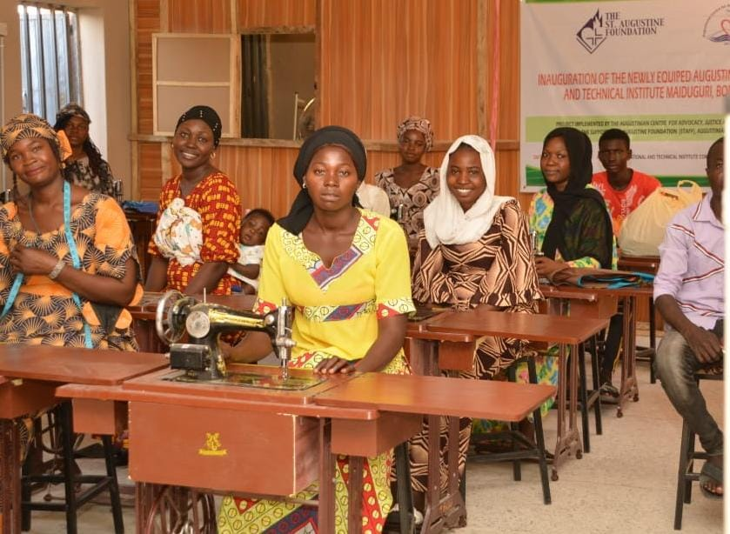

Maiduguri (Nigeria) - Sewing class at the Fr Raymond Hickey OSA Institute

The ‘conservation of nature’ was introduced into the 2008 Constitutions of the Augustinians as far back as 2008 as a pastoral priority, though perhaps the word ‘conservation’ now sounds dated in the light of the more proactive approach today. In 2019, the General Chapter agreed to promote the teaching of *Laudato Si’* throughout the Order and gave the task to the renamed Justice, Peace and *Integrity of Creation* Commission.

The JPIC Commission of the Augustinians, based in Rome, began by informing the JPIC representatives in about forty countries about the information available in both the Vatican Dicastery for the Promotion of Integral Human Development and the Laudato Si Movement (formerly the Global Catholic Climate Movement). Each province and circumscription, therefore, has been encouraged to take their own initiatives regarding care for our common home.

One example is the setting up of a training facility for displaced persons due to the terrorist actvity of Boko Haram in Maiduguri, northern Nigeria. They are taught various skills, like tailoring, carpentry and IT maintenance, all of which encourage the use of local materials and recycling. It also provides an opportunity for Christians and Muslims to mix and break down barriers in an area where religious misunderstanding is a major issue. It is an example of how care for our common home and justice for the poor work in tandem: integral ecology.

The Augustinian Order is heavily committed to education worldwide, especially secondary education. Our schools have been exemplary in promoting sustainable living and care for the environment, often in conjunction with national educational policies, as in Malta. In the Liceo de Cervantes, a high school in Barranquilla, Colombia, they installed solar panels to reduce the school’s carbon footprint by 44 tonnes a year, as well as bringing down the cost of electricity by 40%. In addition, the school donated some panels to an indigenous tribe in Guajira which did not have any electricity, enabling their children to use a classroom now lit by electric light.

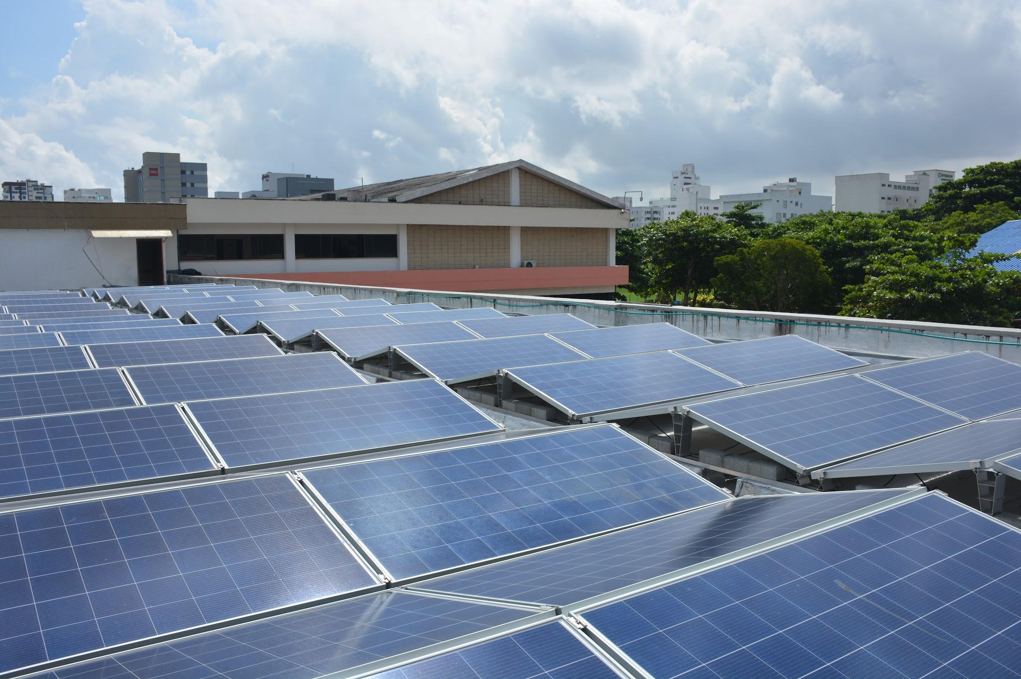

Liceo de Cervantes, Barranquilla, Colombia

The Augustinians in the Philippines, through their Santo Niño Augustinian Foundation (SNAF) [www.osasnaf.com](http://www.osasnaf.com) acquired over 40 hectares of land near Cebu in order to establish housing for the homeless and to teach them how to live sustainably, demonstrating yet again how care for the environment and social justice are interrelated. It is called the Climate Smart Building Project. SNAF’s mission statement is ‘to enable Augustinian-organised communities, especially the marginalised sectors and children, improve their quality of life and safeguard the environment.’

One of the aims of the Augustinians, therefore, is to promote integral ecology by relating social issues to care for the environment. St Augustine himself, though he lived in the 4th century when ‘care for the environment’ was unheard of, speaks movingly of his love for creation and for people to live together in harmony. When this happens, it is a foretaste of the blessed life to come, so that ‘Your works praise you that we may love you, and we love you that your works may praise you’ (*Confessions*, XIII, xxxiii).

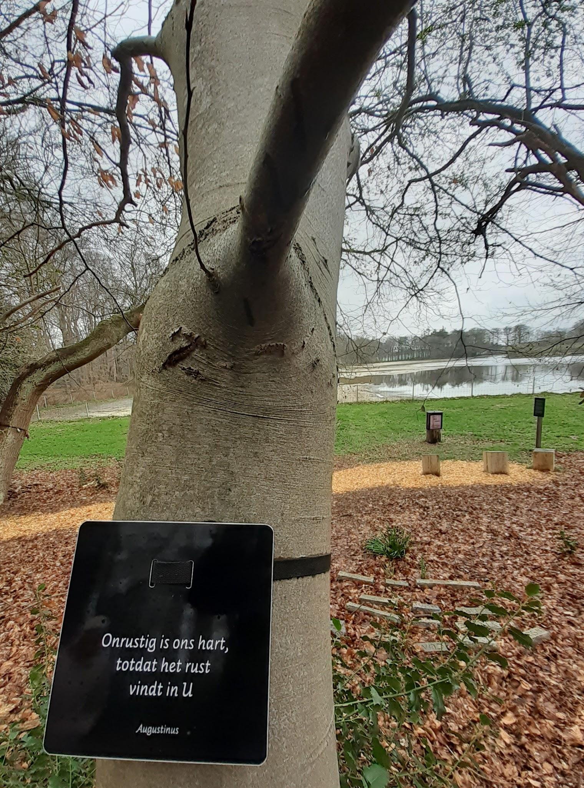

*‘Our heart is restless till it rests in you’*

Casella Augustinian Retreat Centre, HIlversum, Holland.

Nature trail with Augustine.