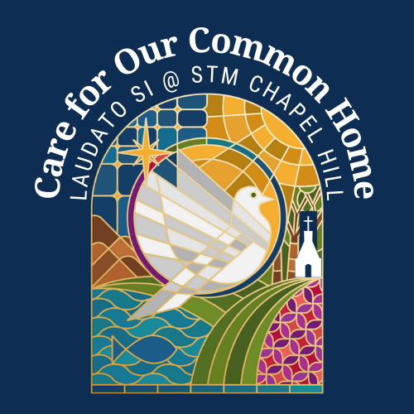**The spirit of Laudato Si'** is one of holism and integral ecology: the manner in which we treat the environment influences our treatment of the poor, and vice versa. The encyclical calls upon all people to fundamentally reject a culture of disposability and strive toward a greater regard for life. In the nearly 7 years since Laudato Si’ was first published, the Environmental Stewardship Committee (ESC) and other ministries of Saint Thomas More Parish have made some significant achievements, including most recently the installation of a rooftop solar array. The ESC has also advocated for the adoption of parish-wide composting and recycling, the use of sustainable building practices in new construction, an energy audit of the facilities, and the maintenance of the San Isidro organic garden. However, the ESC is fairly small, and has limited engagement with the other 130 STM ministries and the greater parish body, including those committed to social justice. The Outreach ministry has ensured STM’s involvement and tangible support for the Interfaith Council food pantry and the coordinated use of STM funds to support local charities. But Outreach and ESC have not connected with each other and with other existing ministries. Given the large and diverse nature of STM (3000+ households), core members of the ESC sought to involve a much wider and more representative population within the parish in Care for Our Common Home. The launch of the Laudato Si’ Action Platform (LSAP) has provided such an opportunity: for reflection, planning, and meaningful change at the local community scale, and involving delegates from our Hispanic community and young adults. We offer the following reflections for areas of improvement within the parish towards better implementation of Laudato Si’:

1. **Participation:** We hope to engage a much larger percentage of the parish in Care for Our Common Home. It’s better to have hundreds of people composting more or less well than to have a few dozen doing it perfectly. We also hope to broaden participation in the LSAP programs - we need people of action!
2. **Communication:** We hope to better inform the parish community about the application of Laudato Si’ at the parish level: what is being accomplished, what responsibility we can and have taken at the local level. We intend to provide timely updates via existing communication channels within the parish, as well as targeted outreach events.
3. **Education:** We hope to improve environmental literacy in the parish. This should involve adult education, faith development at all levels, and supplemental curriculum in the STM School.
4. **Catholic Social Teaching**: We hope to bring greater understanding of Catholic Social Teaching to the parish. Moreover, we hope to establish in word and in action that care for creation does not conflict with, but rather reinforces the dignity of human life. We affirm that social justice and the environment are inextricably linked.
5. **Liturgy:** We hope to incorporate Care for Our Common Home in our community prayer and liturgical traditions. This could be in the Prayers of the Faithful, in the acknowledgement of Creation-centered holy days (e.g. St. Kateri Tekawitha, St. Isidore the Farmer, Rogation & Ember days, etc.), and in special opportunities for community prayer and thanksgiving.
6. **“It’s All Connected”:** Pope Francis has repeatedly emphasized the inter-connections between Creation Care and other sectors: humanitarian, environmental, economic, theological, etc. We hope to bring that spirit of intersectionality and collaborative action to all of our ministries, improving inter-ministry collaboration and more effectively leveraging existing participation.

The Laudato Si’ Action Platform Committee of St. Thomas More