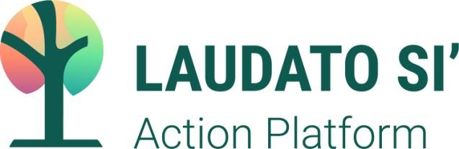 

**Laudato Si’ Action Platform Reflection**

**CommonSpirit Health Embarks on a Seven Year Journey to Promote Integral Ecology**

Recognizing our inherent interdependence on each other and on the environment in which we live, CommonSpirit Health and our community of more than 150,000 caregivers across 140 hospitals and 1,000 care sites in 21 states affirms our commitment to the Laudato Si’ Action Platform. Inspired by Pope Francis’ Laudato Si’ encyclical, this initiative to change the way we think and act in relationship with one another and our fragile Earth aligns with CommonSpirit’s own mission to make the healing presence of God known in our world.

An essential element of that mission is our Climate Action Plan and sustainability program. Reversing harmful climate change and protecting our environment are critical for the health of the people and communities we serve. The marginalized and minority communities we care so deeply about are hurt by climate change, pollution and other environmental damage more than their fair share. As health leaders, we have a duty to do all we can to protect our planet and one another.

To that end, CommonSpirit will continue on our journey to collaborate with others in our global community who are leading the transition to a more resilient, equitable, and sustainable world; to deepen our understanding of what ‘ecological conversion’ demands of us; to promote a culture of caring for all of creation; and to pledge to reach net-zero greenhouse gas emissions by 2040 and cut operational greenhouse gas emissions by 50 percent by 2030. These bold steps to protect and value that which sustains life are an essential part of improving health for all and answering Pope Francis’ call to set out “on the long path of renewal.”

 We have a heartfelt mission that compels us,

an optimistic vision that inspires us,

and the healing power of humankindness that unites us

as we seek to address the seven Laudato Si’ Action Platform goals to:

Respond to the cry of Earth and the cry of the poor,

Adopt a more sustainable lifestyle

Engage in and foster ecological education

Embrace ecological economics

Develop an ecological spirituality

Enhance Community Involvement and Participatory Action

that protects our common home and all those who share it.