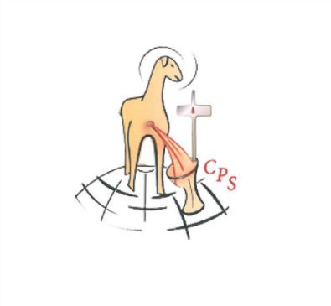

**Missionary Sisters of the Precious Blood**

**Commit to Laudato Si Action Platform**

Dear Sisters, at our Provincial / Regional Superiors’ Meeting in the Mother House, Heilig Blut, the Netherlands, June 2019, we recommitted ourselves

*to make JPIC our way of life which becomes evident in prayer, community living of the vows, finances, care of the environment etc. Sisters are encouraged to use Laudato Si as resource material for ongoing formation.*

Since 1997, our General Chapters have encouraged us to become aware of the important issue of the ***care for and preservation of creation***, a topic that was very dear to our Father Founder Abbot Francis Pfanner, who lived with nature and cared for the preservation of the natural environment, while at the same time making good use of its various substances.

As well, our Constitutions clearly hold out a responsibility for us:

*Our Precious Blood Spirituality challenges us to become instruments of*

*reconciliation, justice and peace and to preserve the integrity of creation.*

Const. # 507

It springs right from our Charism that calls us to live the Paschal Mystery and to witness to the redeeming love of Christ by making the Precious Blood fruitful through our apostolates. It is radical Gospel living through solidarity with the marginalized and a non-violent approach to all life. A spirit of reconciliation with all of the creation is an indispensable aspect of our charism. We have lived and continue to live the values of JPIC in our various ministries as we serve the underprivileged and marginalized like lepers, homeless children and vulnerable adults, refugees and immigrants, and in our care for the preservation of creation. In a prayerful discernment of the “signs of the times” we are to see the needs, judge what is our role, and then act as followers of Jesus Christ. Our concern for our *Common Home* is reflected in all the named *Laudato Si* Goals.

In responding to Laudato Si’s call to integral ecology, we want to consciously and conscientiously continue the initiatives and efforts that we have already started in our Provinces and Regions as we pledge to walk the 7 year journey to ecological conversion. Our commitment to justice, peace and integrity of creation prompts us to join and be part of the large network of individuals and collective initiatives towards this journey. We all as individuals and communities have the opportunity to do something starting with small but concrete steps as Pope Francis reminds us in LS

*All of us can cooperate as instruments of God for the care of creation, each according to his or her own culture, experience, involvements and talents.* # 14

We would like to strongly support and promote the Laudato Si Action Platform on Care for our Common Home.

Therefore,

We publicly commit to join the worldwide Catholic community in responding to Pope Francis’ appeal to participate in a seven-year journey toward sustainability and integral ecology by developing a Laudato Si’ Action Platform.

This commitment marks our willingness:

* To take up the “urgent appeal” of *Laudato Si’* to listen and respond to the cry of the Earth and the cry of the poor by making it a community priority;
* To further our ongoing ecological conversion by bringing our members into greater understanding of their socio-ecological vocation within the spirit of our charism;
* To integrate each of the seven *Laudato Si'* goals into our life and apostolates by developing a systematic process to transition to an integral ecology;
* To take bold concrete actions in the spirit of *Laudato Si'* to address the multiple crises afflicting our common home – the planet and its people.
* To practice nonviolence, as we reconcile and heal the pain in creation and sow hope for peace.

This commitment is made in faith, hope, and love, knowing that we are participating in God’s work of transformation, “for we know that things can change” (LS 13).



Signed by General Superior

28 January, 2022

Name: Caroline Mjomba, CPS

**Laudato Si’ Action Platform contact person**

[www.missionarysisterspreciousblood.org](http://www.missionarysisterspreciousblood.org)