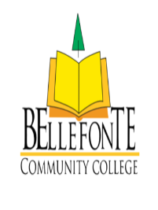

**Lumshyiap - Shillong, India**

**________________________________________________________________**

**Reflections on Laudato Si**

For many people around the world, Laudato Si has been a wake-up call. The necessity of caring for our common home has been emphasised by Pope Francis. Reflecting on this document has aided me in reflecting on my own actions and attitudes toward God and his creation. The phrase "since everything is connected" is a clarion call for everyone to use the environment responsibly.

Following considerable thought and planning for a better and cleaner environment, the institute resolves to take the Laudato Si Project seriously by organising a variety of activities that will foster a strong sense of love and care for our common home, leading to ecological balance. It will also give a platform for our students to raise environmental awareness among their peers and act as change agents.

The institute also intends to collaborate with other organisations, both governmental and non-governmental. It will also undertake a number of initiatives to promote a culture of caring for all of creation, as everything is interconnected, and to promote a simple, healthy lifestyle.