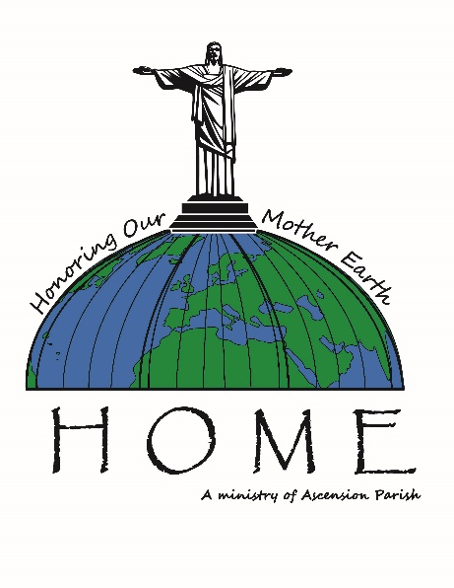
ASCENSION PARISH, OAK PARK, IL is a vital Catholic church, school, and community, established in 1907. We have excellent lay leadership and are known as a Peace and Justice and Music and Worship congregation. Ascension has a vibrant Creation Care Ministry created at the launch of Laudato Si’ in 2015. It’s called HOME, Honoring Our Mother Earth, and the acronym connects to the subtitle of the encyclical, “Caring For Our Common Home.” We function under the umbrella of our long-standing and vibrant Peace and Justice Committee.
We are inspired by the comprehensiveness and integral ecology eloquence in Laudato Si’ and we feel the Holy Spirit at our backs. There was and is a great reception for it in our church and community. Environmental advocates and activists were waiting for an opportunity to do this faith-based work.
With over 20 members, good parish support (fostered), an impressive Advisory Committee and some successful and ongoing initiatives, we are grateful and continue growing our ministry. We won a state award for our Green Team Creation Care initiatives from Faith In Place several years ago.
We yearn for parishioners to take more actions to remediate climate change, and we hope they hear the cry of the earth and the cry of the poor. Yet data on parishioners’ actions is not available. Some other ministries also actively support Creation Care. Others will be encouraged.
Some Creation Care accomplishments of Ascension’s HOME team and other ministries since 2015:
THE HIGHLIGHTS:
- Laudato Si’ Gardens Galore! We hear the cry of the marginalized and help with food insecurity. And we attract pollinators and Monarchs with our native plant gardens.
  - A large Community Veggie Garden with over 14 raised beds where over a ton of produce is grown and donated each growing season to our sister church, St. Martin de Porres in the Austin neighborhood of Chicago, for the food insecure. This is a mutual effort with a team from each church
  - Two student STEM veggie beds and a hydroponic garden
  - Several native flower and plant gardens as well as beautiful annual and perennial flowers, including three Mary gardens and one with St. Jude.

- We launched our Zero Waste effort in the school lunchroom and throughout the parish. On launch day in the school lunchroom, we got down from 83% to 15% landfill!

- The HOME team has made a Creation Care/STEM connection with our wonderful school and staff and remind them that Laudato Si’ can be a vehicle subject to teach religion, science, math, civics, art, music and more. We have taught a Laudato Si’ 4-day Religion class to 6th – 8th graders; spoken to the teachers and school staff; shared Laudato Si’ information, books, and resources; and helped create a Creation Care Green Club with the students.

- Lenten Carbon Fasts for five years in a row to assess our carbon footprint and reduce energy use, waste, and consumption in line with Catholic Social Teaching.

- We put important, targeted Creation Care information, graphics, video clips and more in our parish publications. We are grateful for the support. Now it’s time to act!

- We have done some Laudato Si’ events to educate, inspire, act. We hosted several films, including an entry for the One Earth Film Festival which attracted over 200.

- We had an energy audit, funded by Faith In Place, in 2015. We have begun to make these upgrades to save money and energy.

- We have an opportunity for Community Solar for churches in our village. This would be a win-win to save money and to help remediate climate change. We need more support from the Archdiocese and their ability to deal with the complex ComEd contracts. Please focus on this Community Solar option for parishes, parishioners, and local businesses to reduce energy, save money and help create good green jobs. The Archdiocese has a lot of roofs and land to honor God’s Creation in these actions supported by Laudato Si’.

- Music and Worship makes sure that we often pray and sing for God’s Creation. We yearn for more pulpit support for Creation Care, especially to teach that climate change actions are part of Catholic Social Teaching. Climate change is here, now, even in the Midwest and it hurts the poor more strongly. Climate change mitigation is so urgent that Pope Francis is putting a seven-year focus on Creation Care. We’ve got a lot of work to do, but we can do it!

- Peace and Justice has been a dynamic force for nearly 40 years to hear the cry of the disadvantaged. They do so much and hosted several Creches from Around the World events after Christmas. Climate change continues to affect the poor and causes more climate change immigration and asylum-seeking, which will grow exponentially.

- Adult Lifelong Learning has had presenters speak on Creation Care and Laudato Si’.

- Our HOME team logo is symbolic of our work and is Christ centered. Jesus stands on our parish’s dome and the dome becomes Mother Earth, our common home.

- We ask the Archdiocese to divest from their fossil fuel stocks to be in alignment with Laudato Si’, to protect Archdiocesan assets at this delicate time and to communicate this Laudato Si’ action to the Archdiocesan faithful so they will also divest. We have been part of the divestment postcard campaign.

- We yearn to meet people where they are and engage them. An interactive project is being planned to get “cool points” for doing actions to reduce energy, waste, consumption during April Earth Month. Making it fun can and will engage more people. We need the masses!

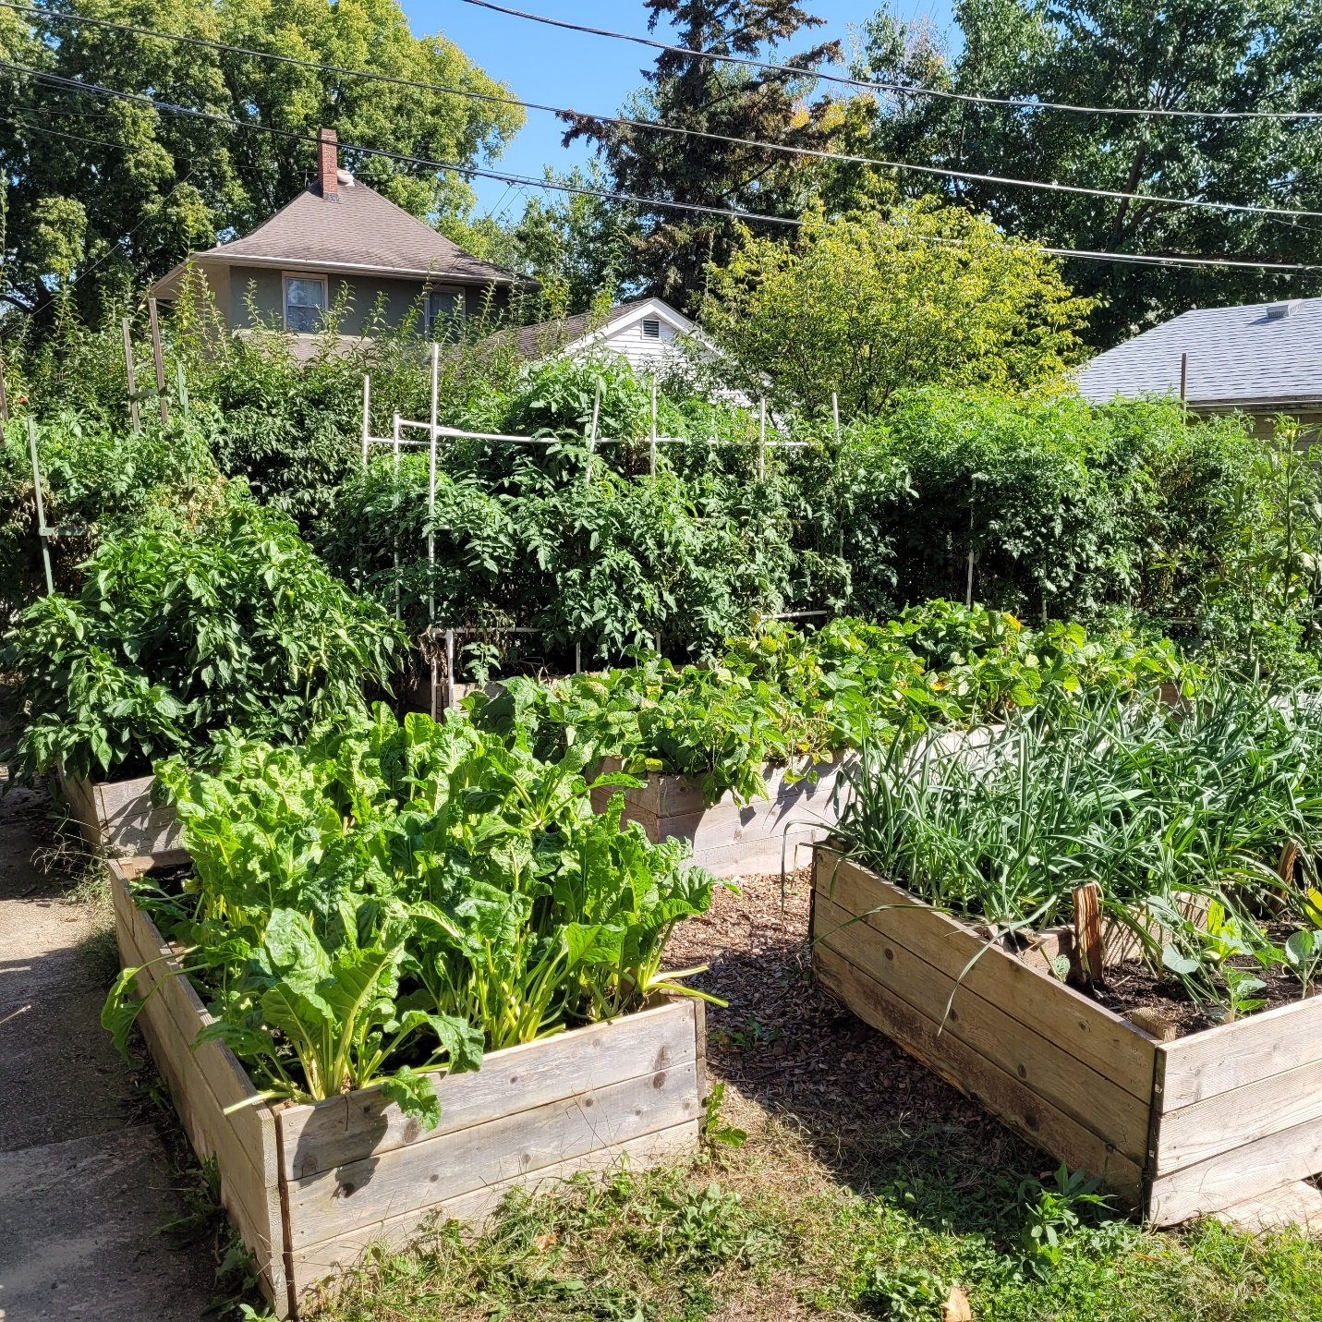
Ascension Community Garden
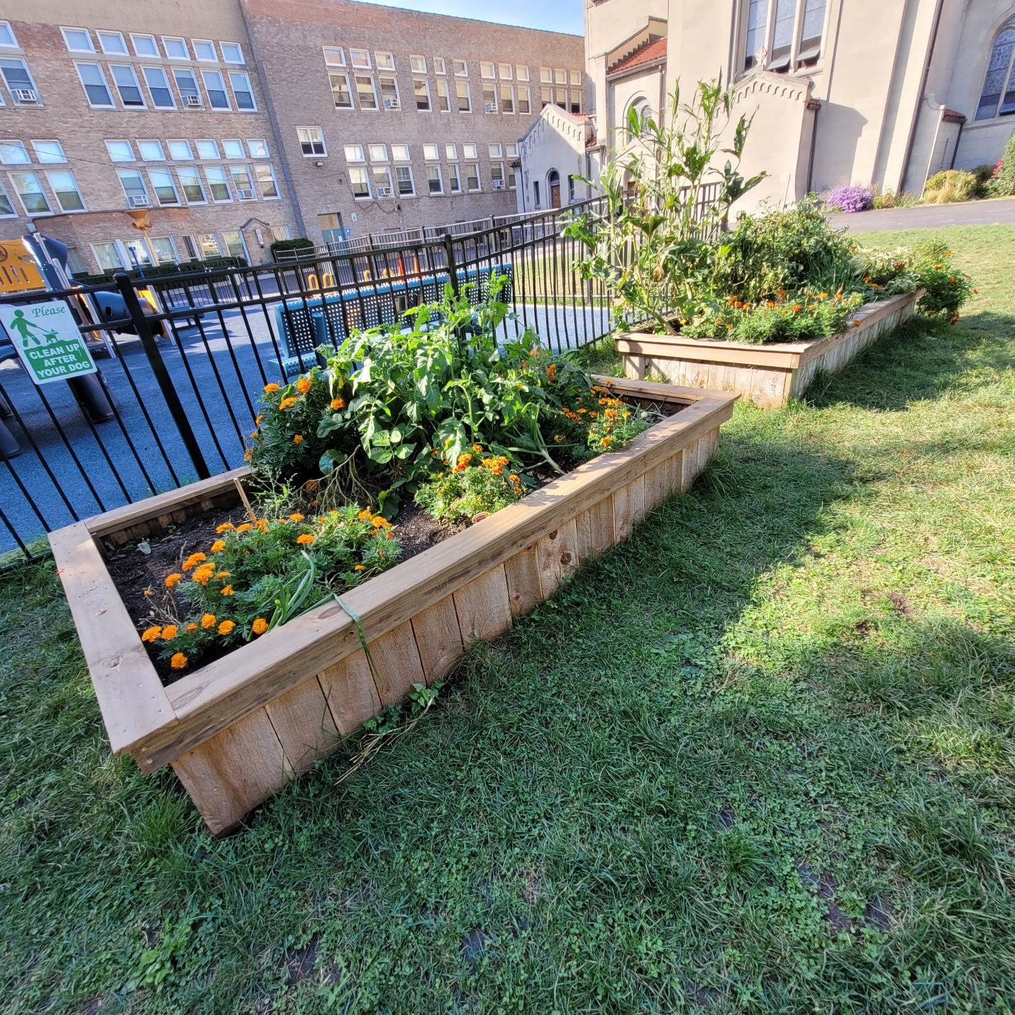
Ascension school veggie bed

Wonder at the cosmos
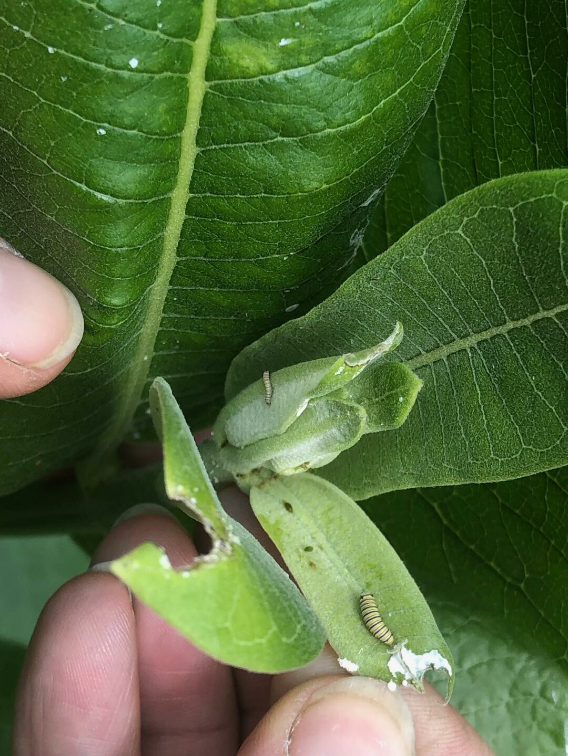
Monarch larvae at Ascension

Ascension HOME team members at Climate March, September 2019

